**CLOUD COMPUTING COURSEWORK**

1. Deploying Java Web Application to Cloud

Started off by opening AWS and going to EC2 on the Services Dashboard

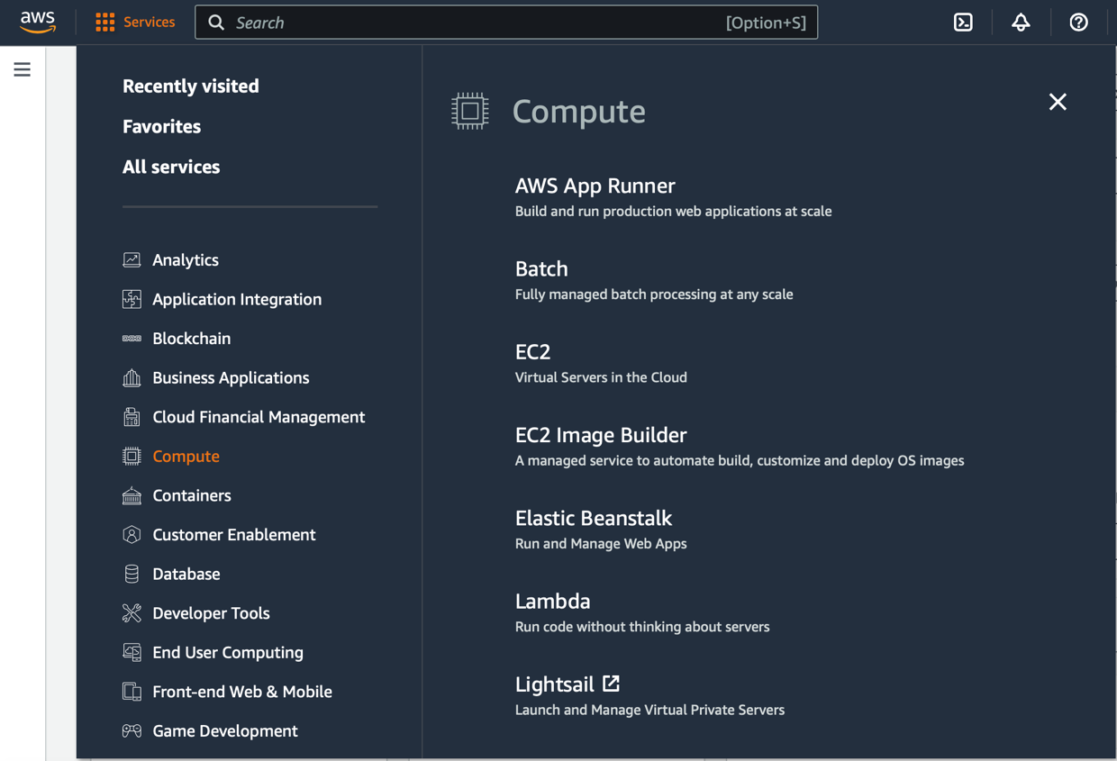

An instance is created by clicking on **Launch Instance**

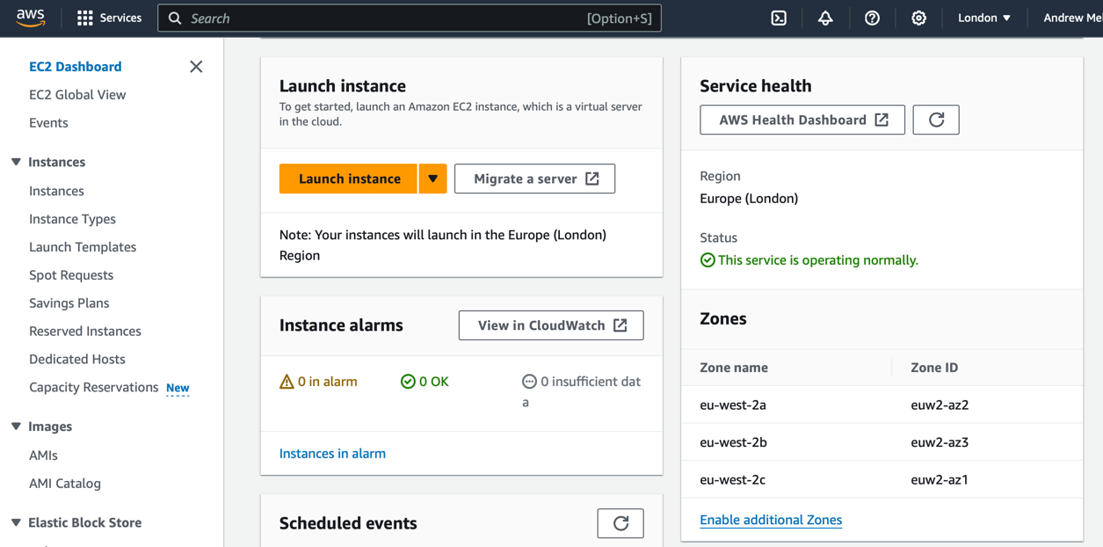

Ubuntu is selected for the VMs Operating System along with **micro** for the instance type

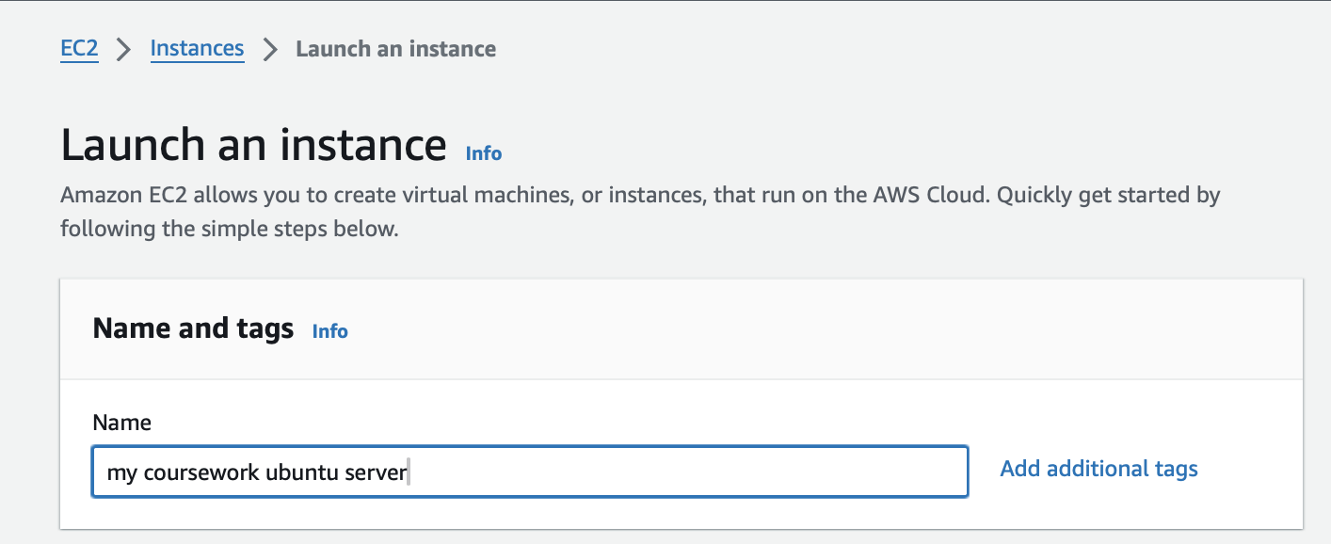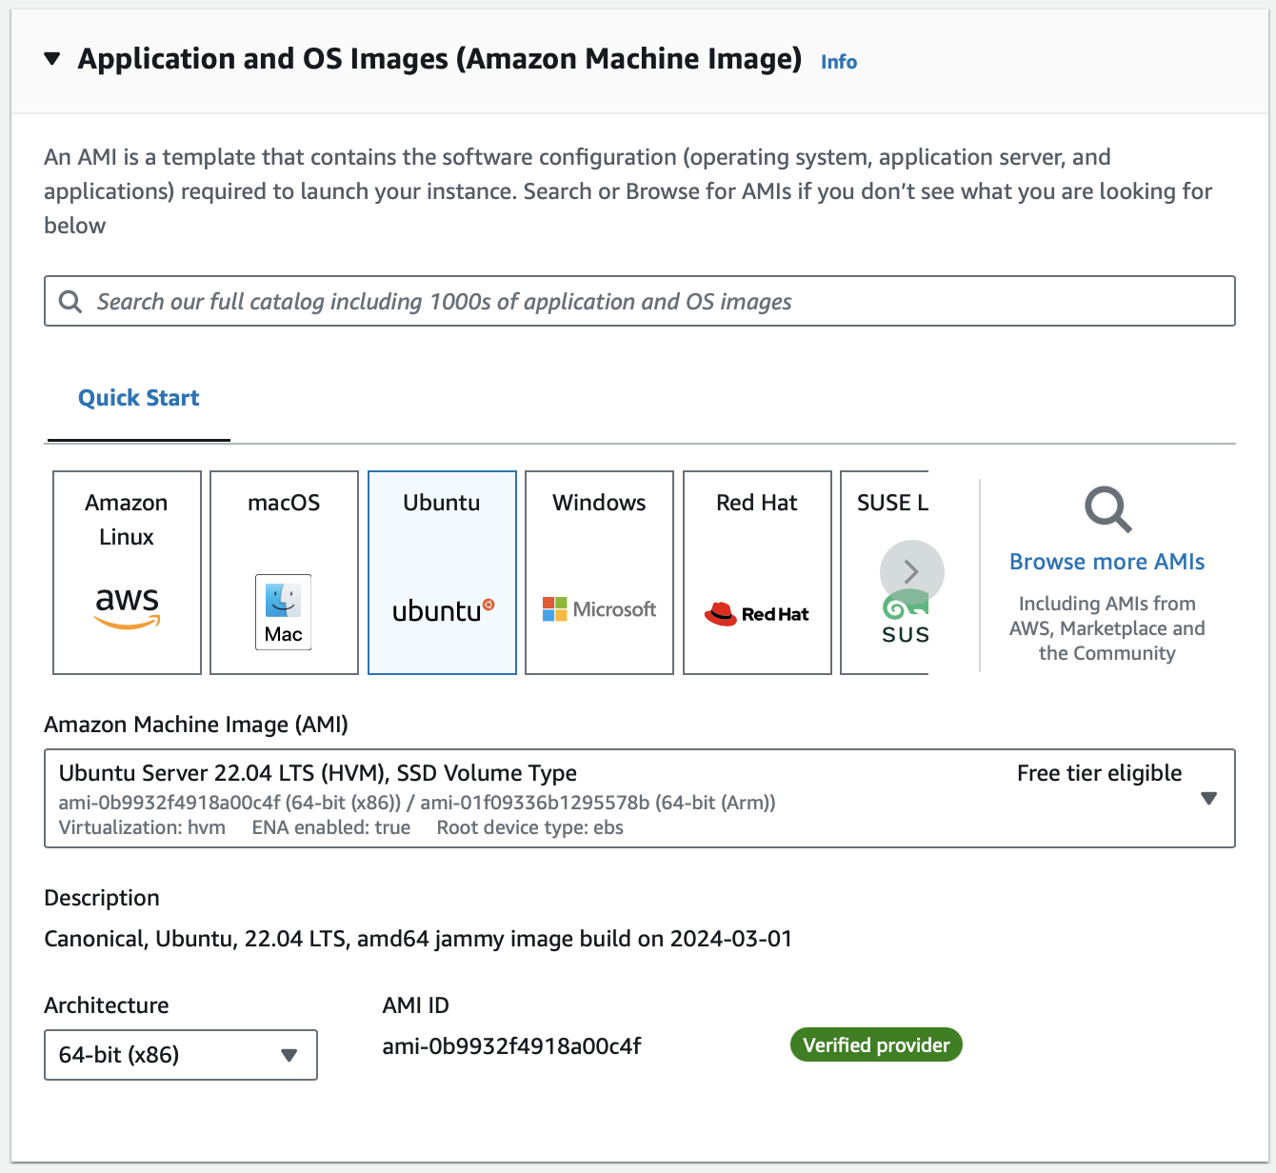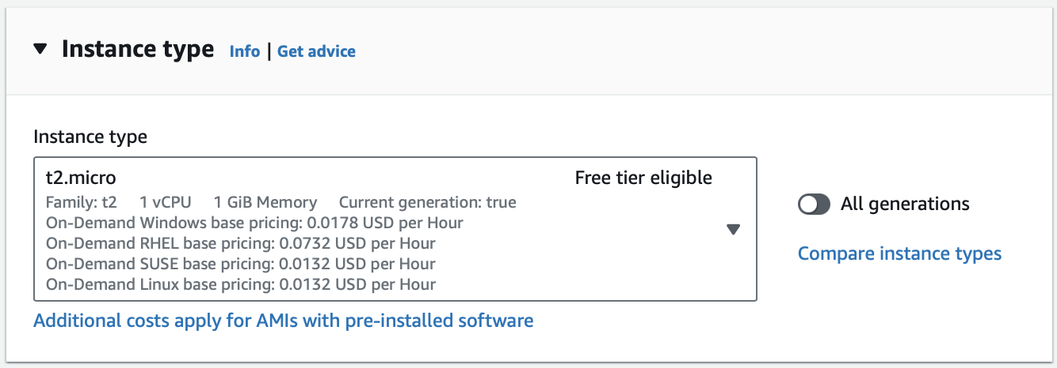

A key pair is then created to access (SSH) the VM

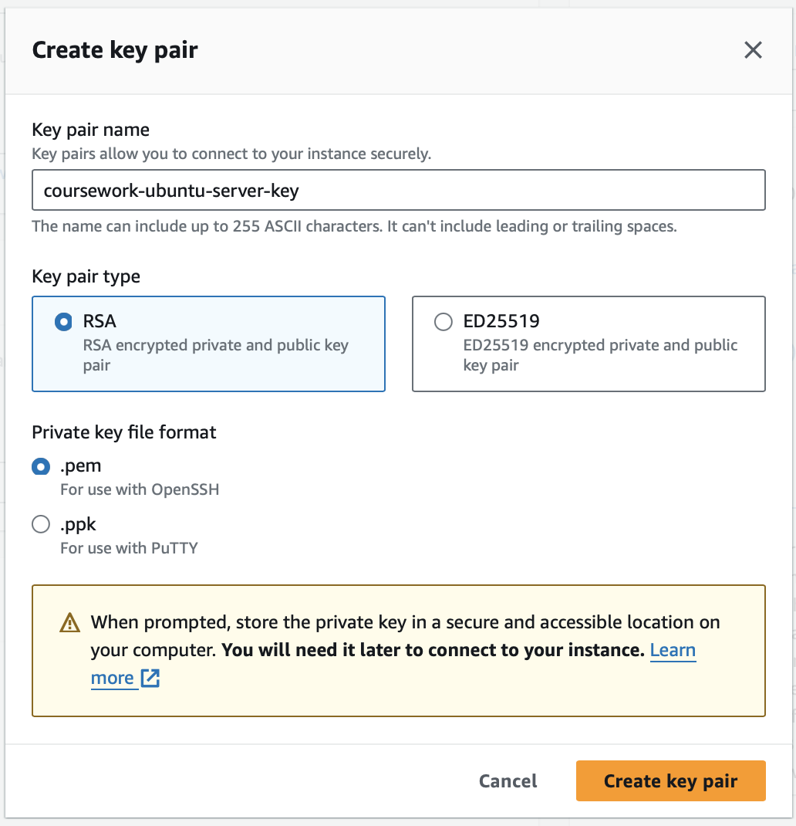

And **allow SSH traffic from** box is checked off before finally launching the instance

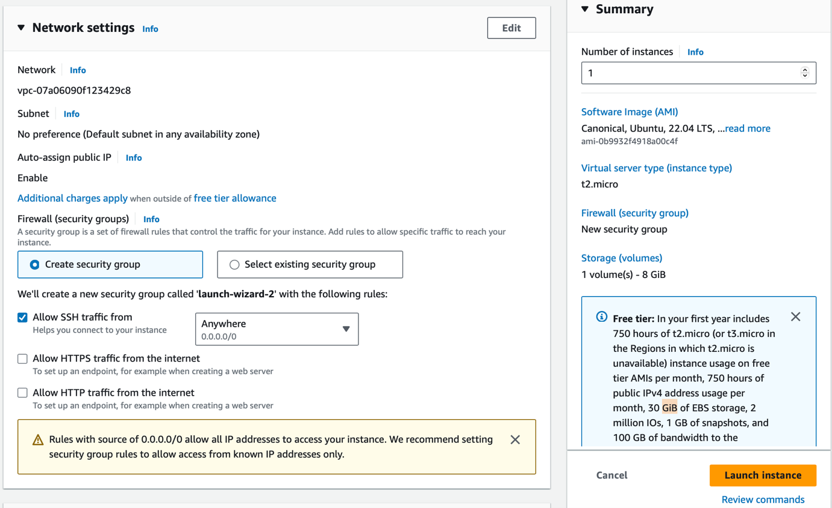

The instance is launched and can be viewed by clicking **View all instances** at the bottom of the page.

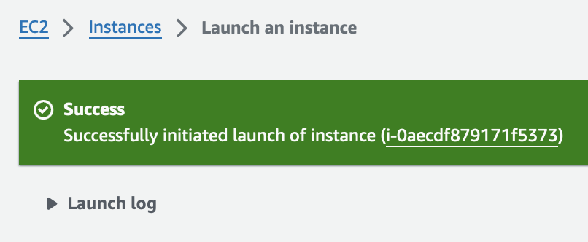

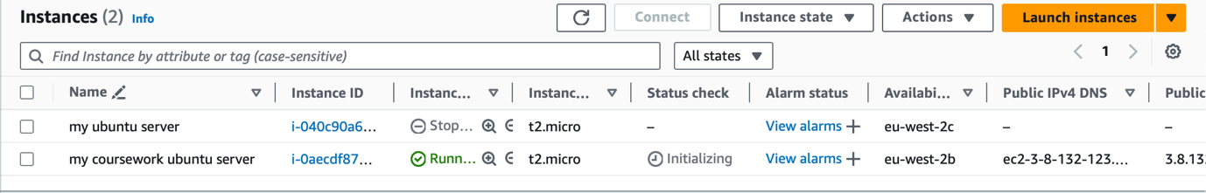

The ports need to be configured as all ports except port 22 are closed for security reasons. I accessed the Security Group by going to **Network & Security** > **Security Groups** and clicked on the relevant **Security Group ID**

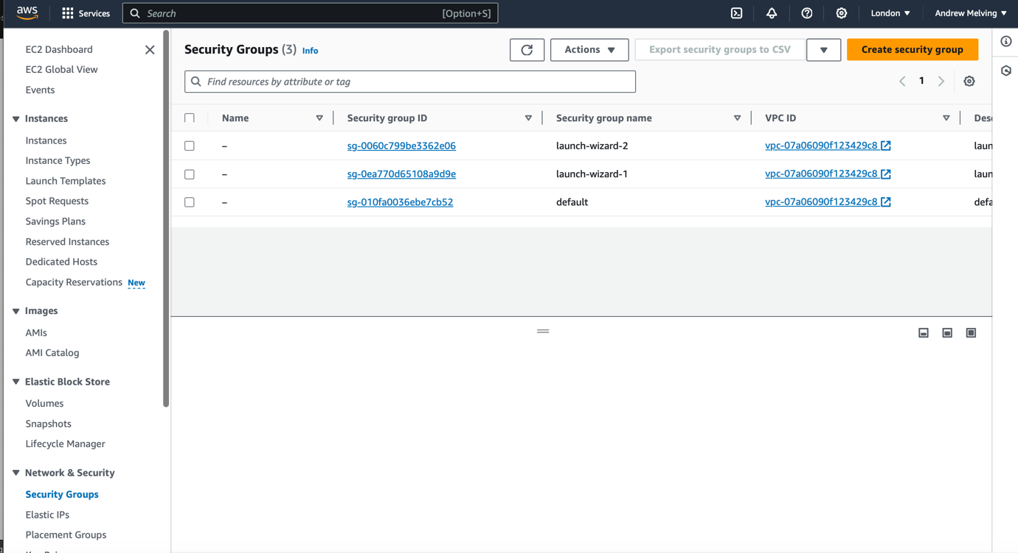

Once selected, inbound rules were edited to open ports below

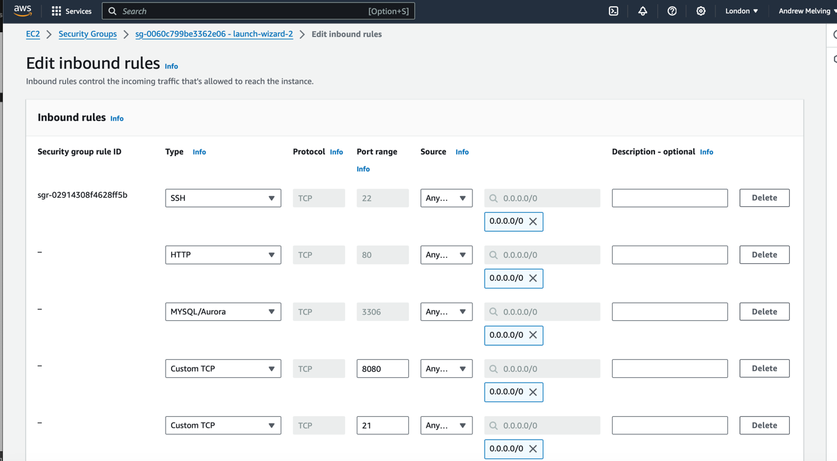

To establish an SSH connection, I right clicked on the instance and clicked **Connect**.

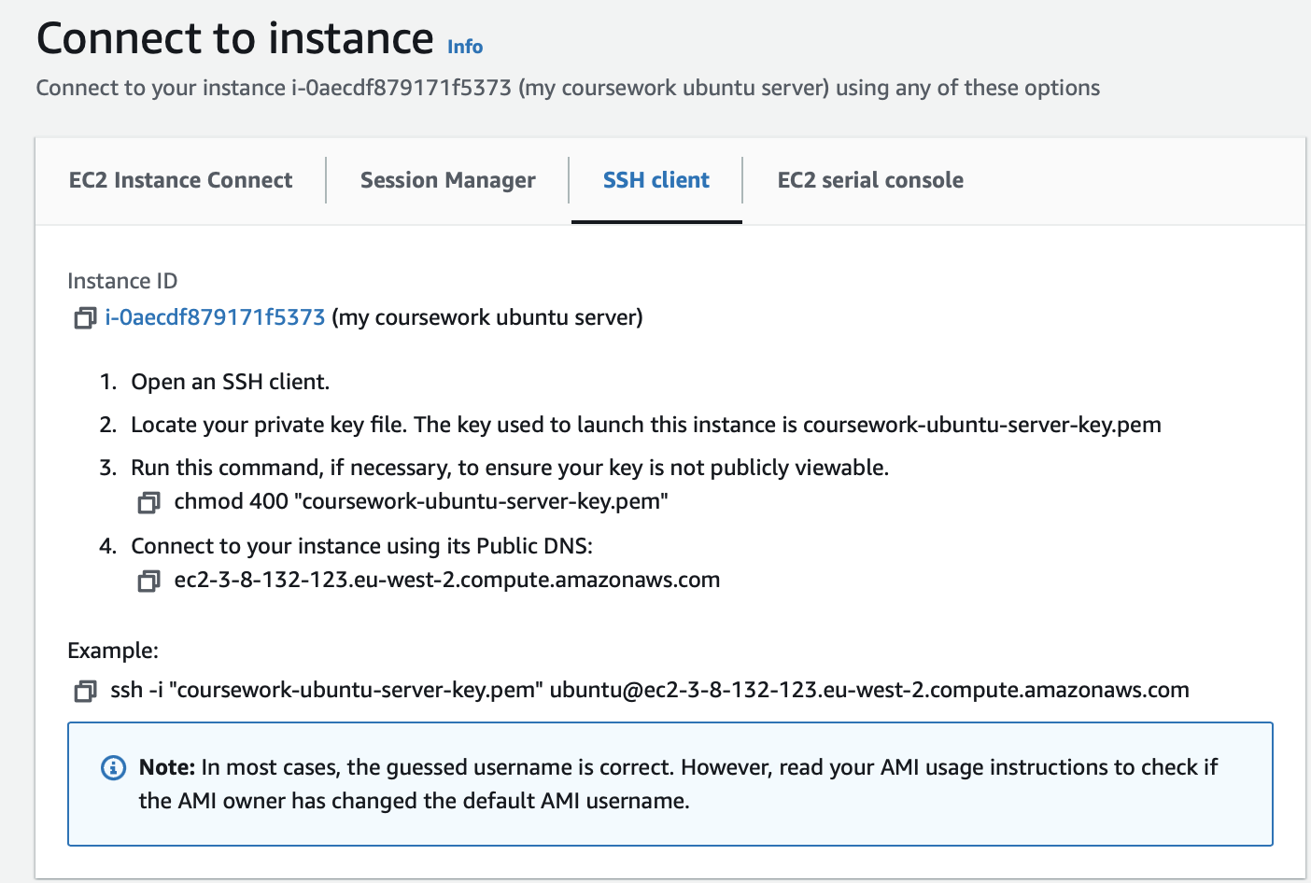

I had to run this command to make sure key was not publicly visible ,



then ***ssh -i "path_to_key” instance_ip*** was inputted into terminal (Mac OS) using [ubuntu@ec2-3-8-132-123.eu-west-2.compute.amazonaws.com](mailto:ubuntu@ec2-3-8-132-123.eu-west-2.compute.amazonaws.com) as the instance ip to establish a successful SSH connection

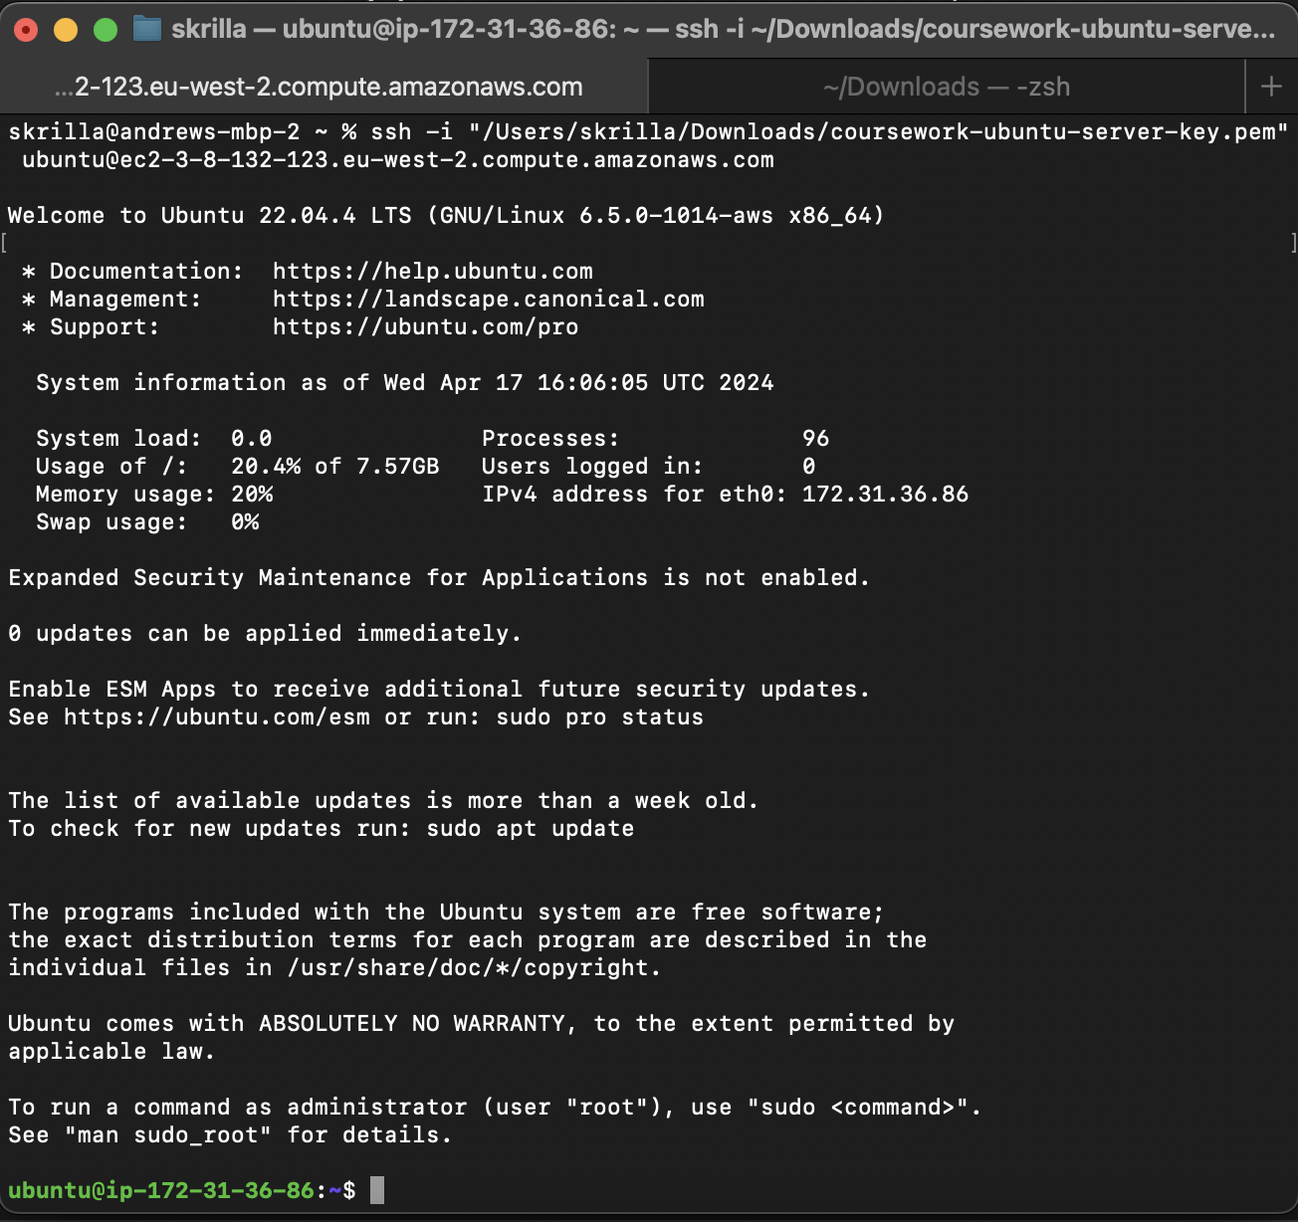

Installing Tomcat and JDK

I used **sudo apt update** is used to update repositories and installed the JDK on the server using **sudo apt install default-jdk**

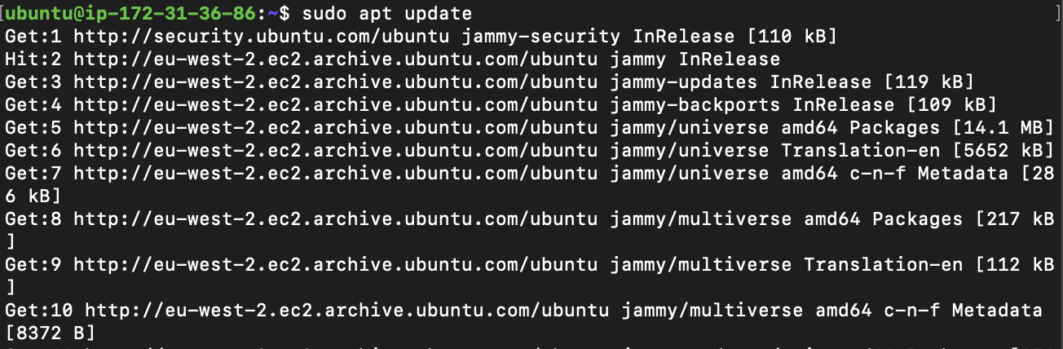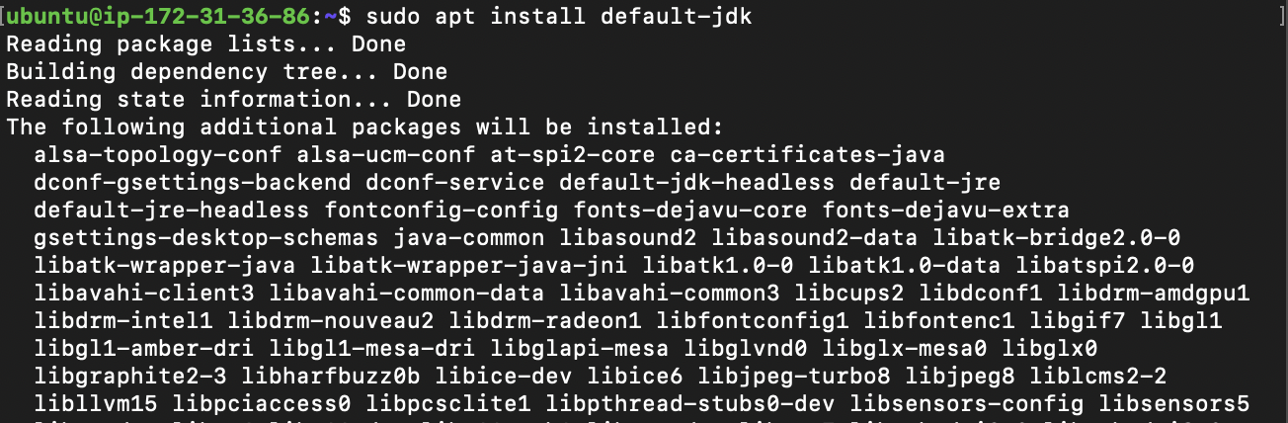

Then created tomcat installation folders alongside a tomcat user (**u21441545**). Users cannot start with a number so ‘u’ is placed before my Student ID.



Tomcat is installed and the extracted archive contents are moved to the tomcat folder

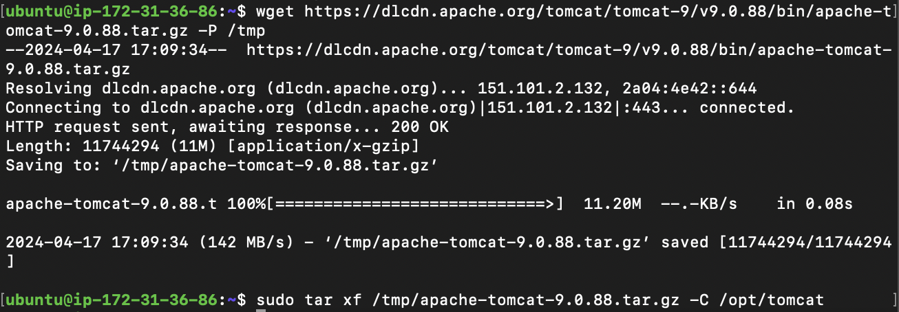

Symbolic link created pointing to Tomcat installation directory and directory ownership to tomcat user is changed.



Tomcat scripts are made executable and a service file is created that allows tomcat to run as a service on the server



After the **sudo nano /etc/systemd…** command, this file editor appears and the **User** and **Group** are set to **u21441545,** the username

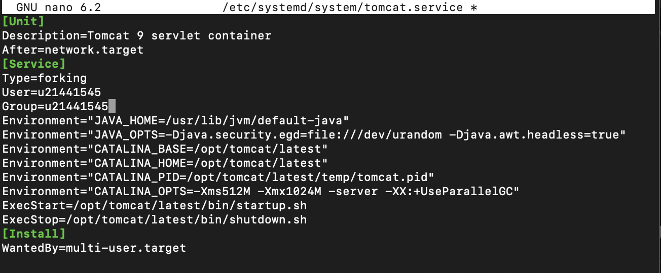

Before starting tomcat, the server needs to be refereshed

Finally tomcat is started and checked if it is running properly

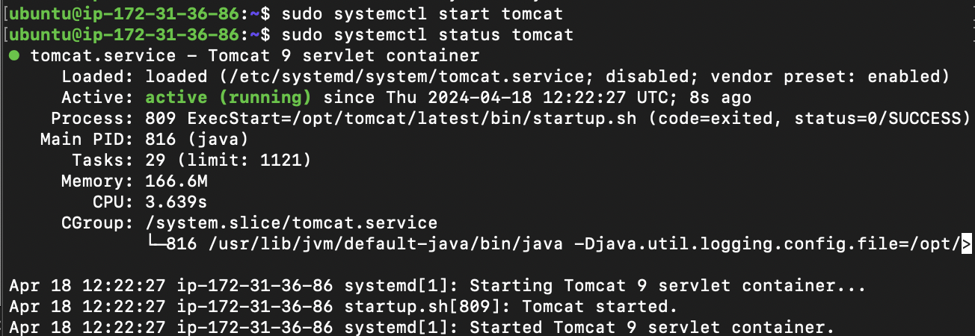

To ensure tomcat is started when server boots the following command is used



And the 8080 port is opened on the server for communication with external users



My tomcat page appears using the public IPv4 address using port 8080

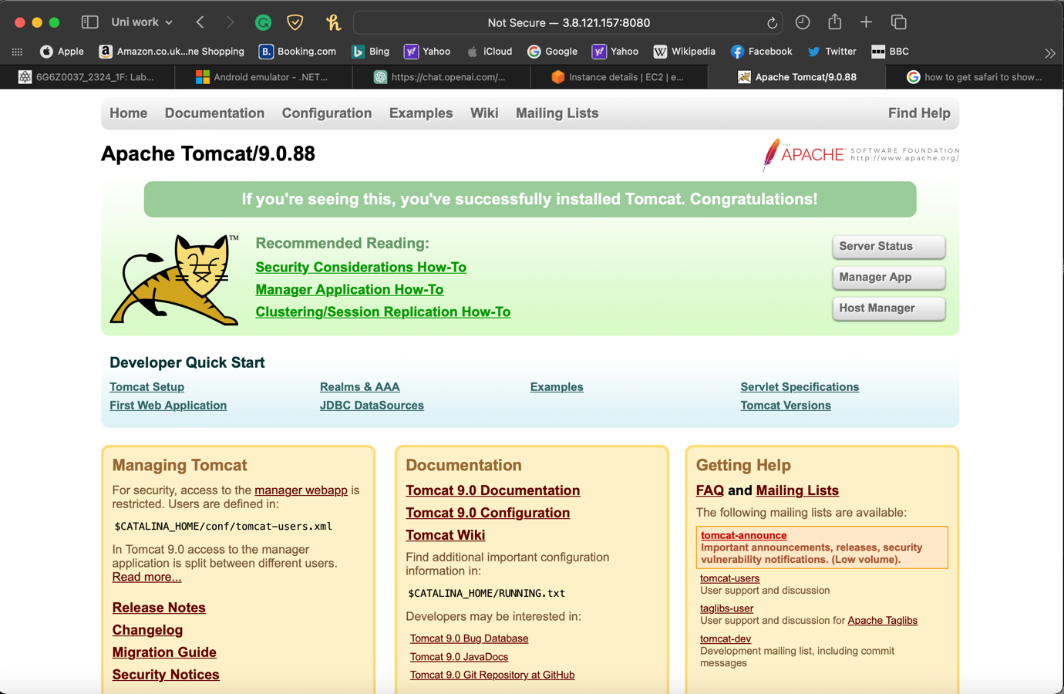

A user is then created using my student ID, **21441545** changing the original username (admin) and password.

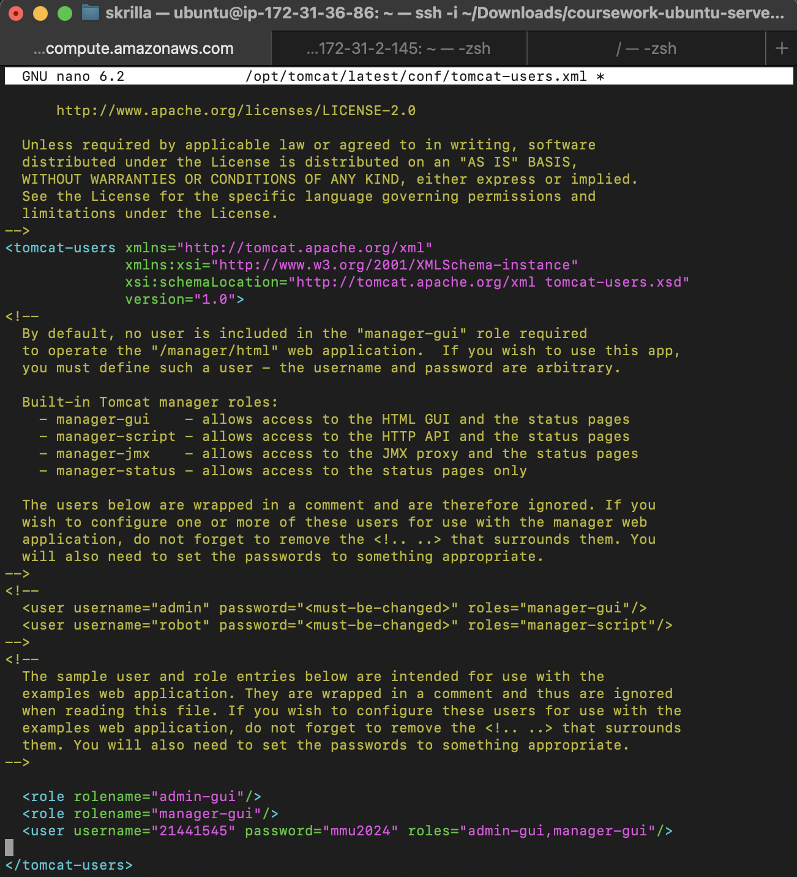

Finally, tomcat is restarted to update changes  


To ensure full access is gained to tomcat, I clicked on the **Manager App** and entered the required details

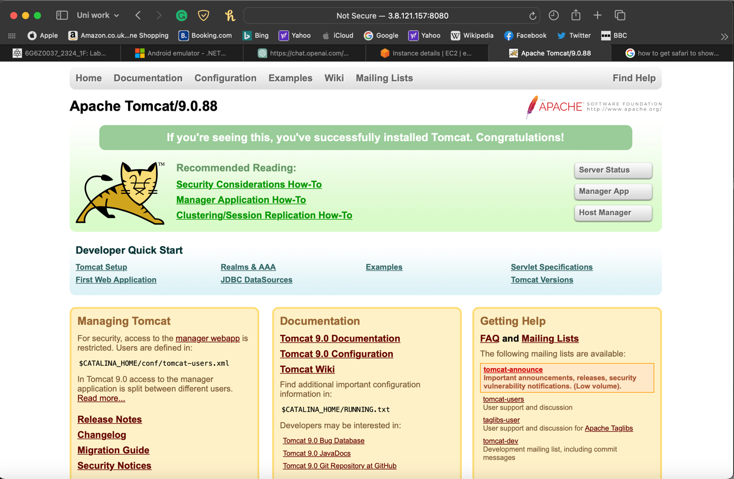

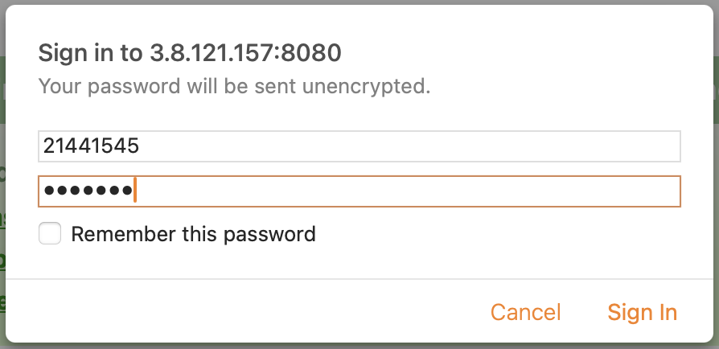

Once signed in, the interface to deploy WAR files appears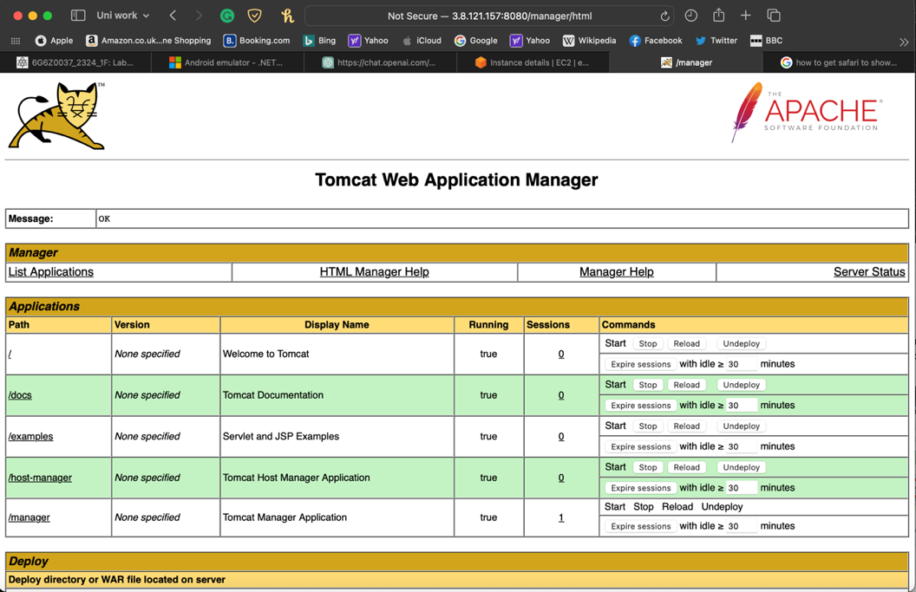

Once deployed, the **/dvdWebApp** should appear on the **Applications** section

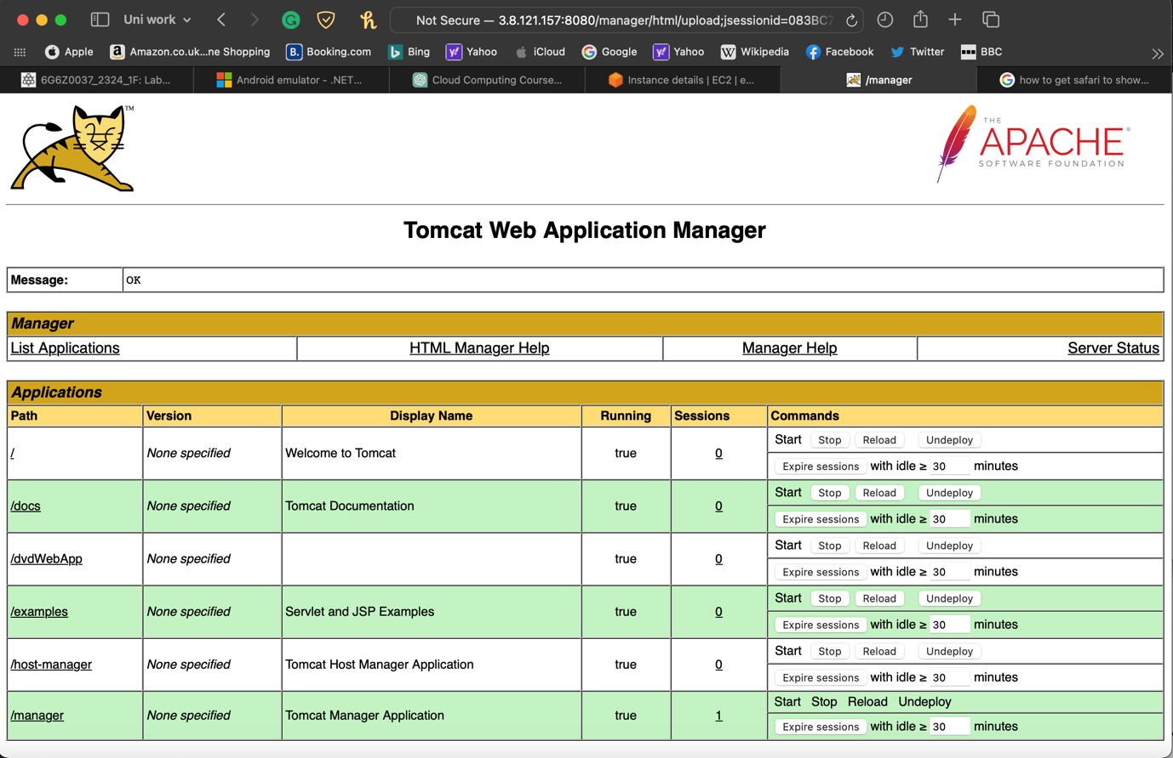

I have already connected the DB to the DVD app (Part 2) and added a movie to check its working

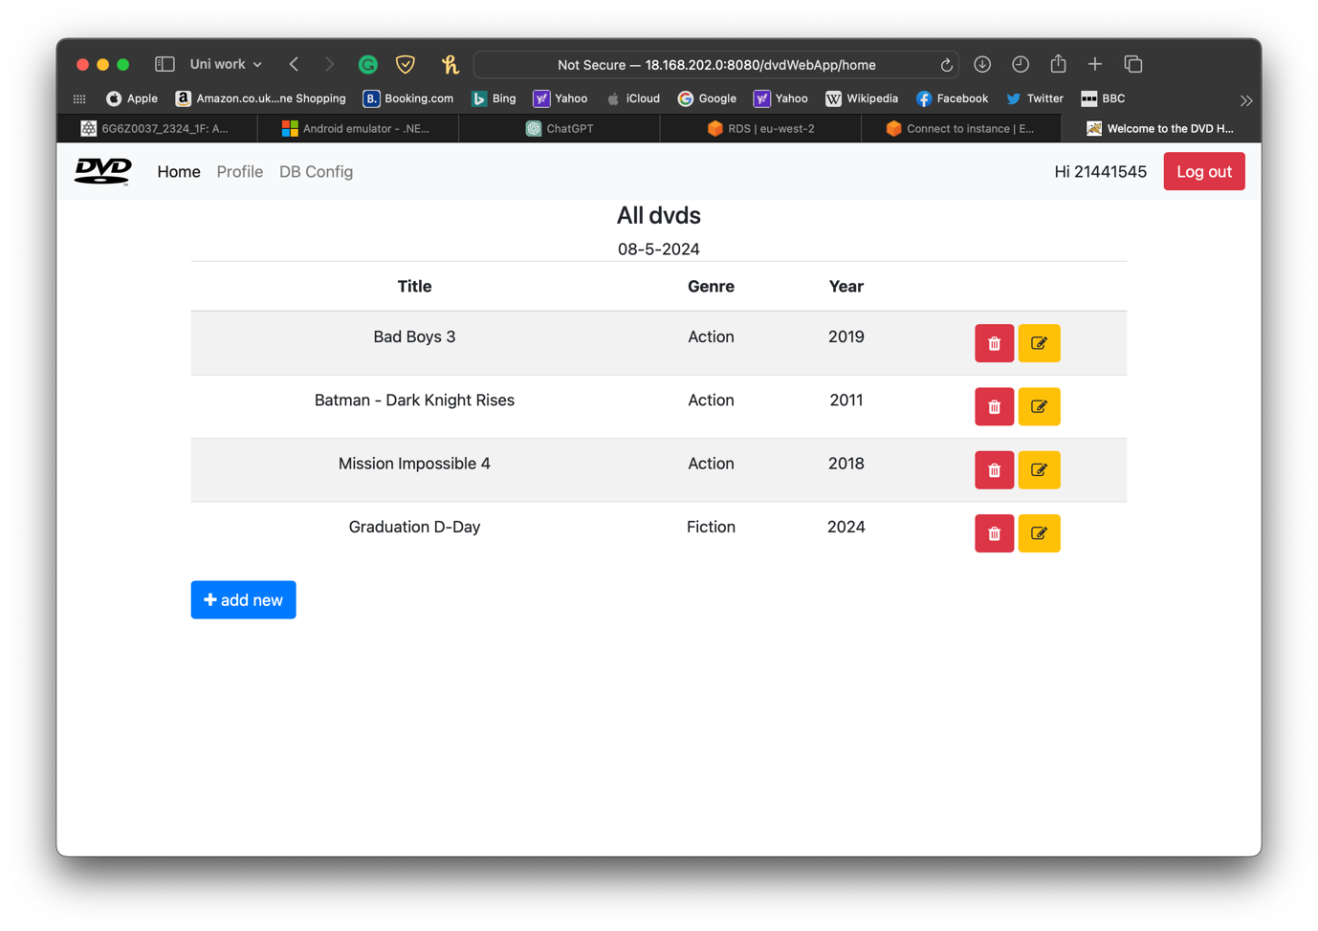

1. Database

I will be using AWS RDS to set up my database. First I went to **Services > Database > RDS**

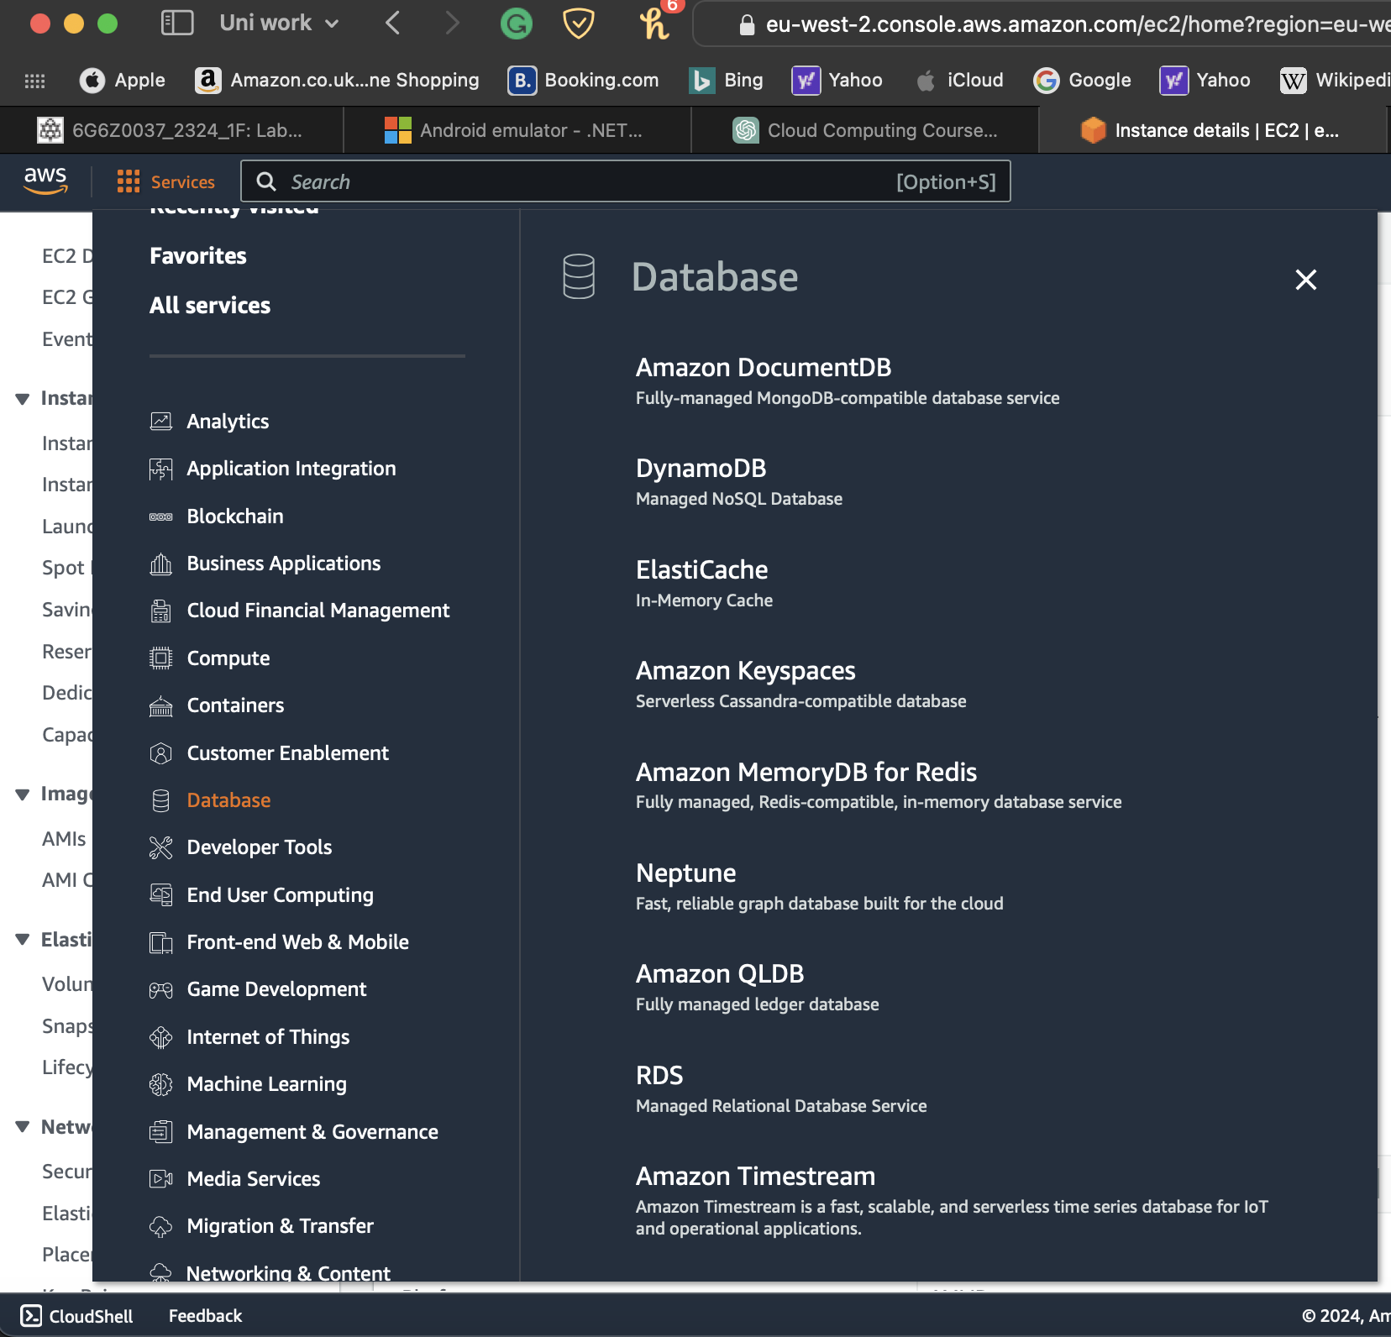

Selected **Create Database** to make a new DB

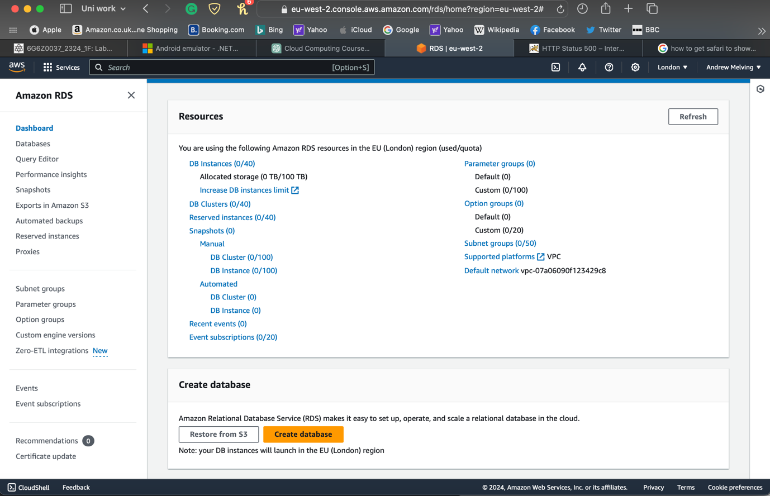

**MySQL** is the engine option picked using **standard create,** alongside the free tier option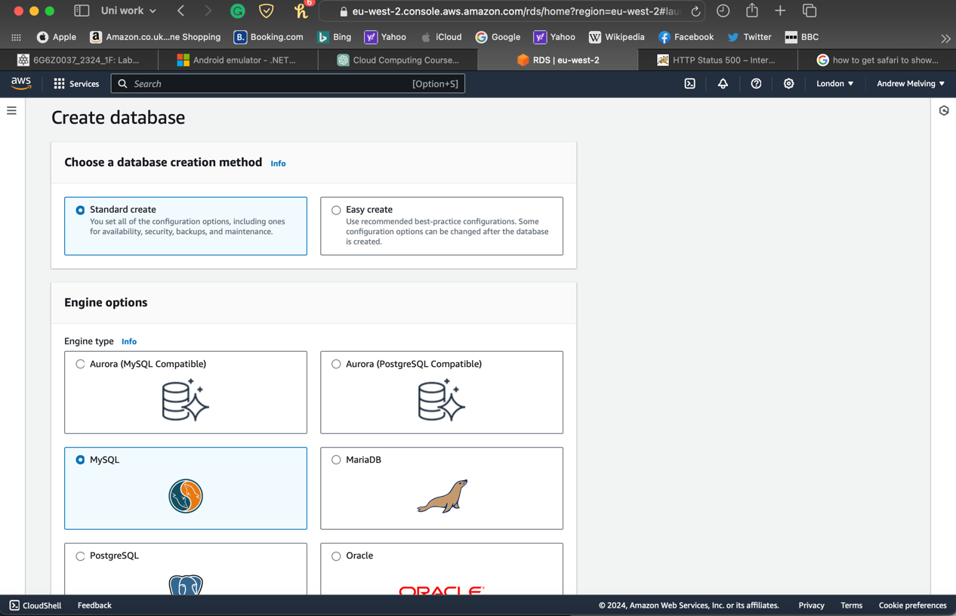

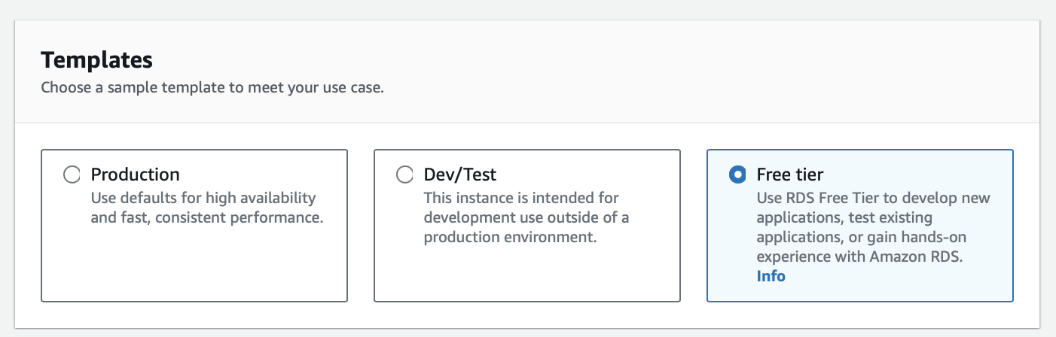

Credentials settings are filled with **master username** and **password**

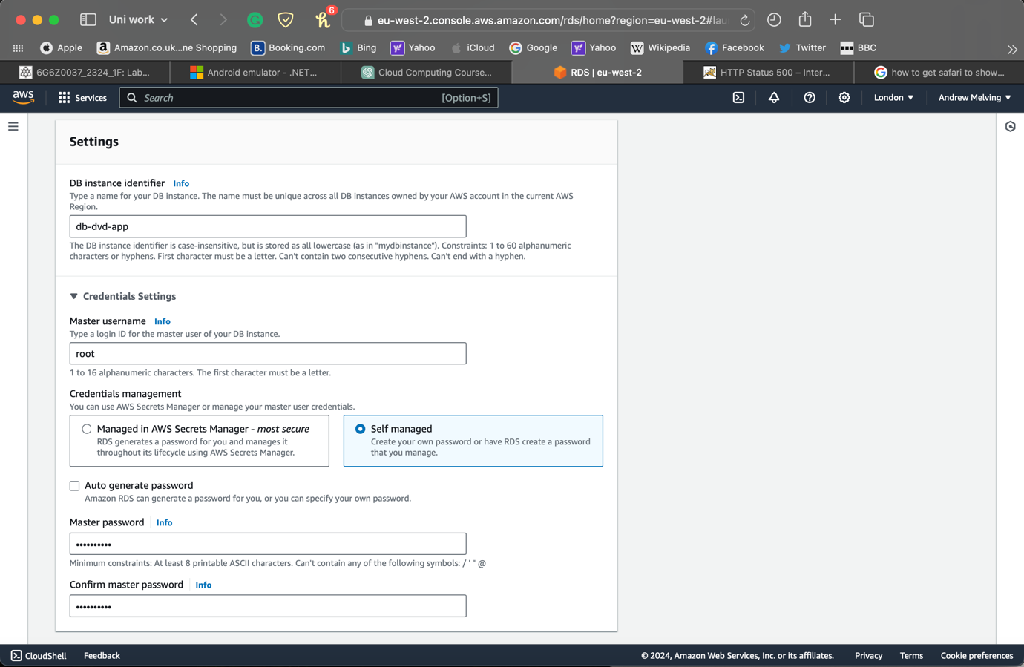

Made sure the DB is publicly accessibile under the **Connectivity** settings

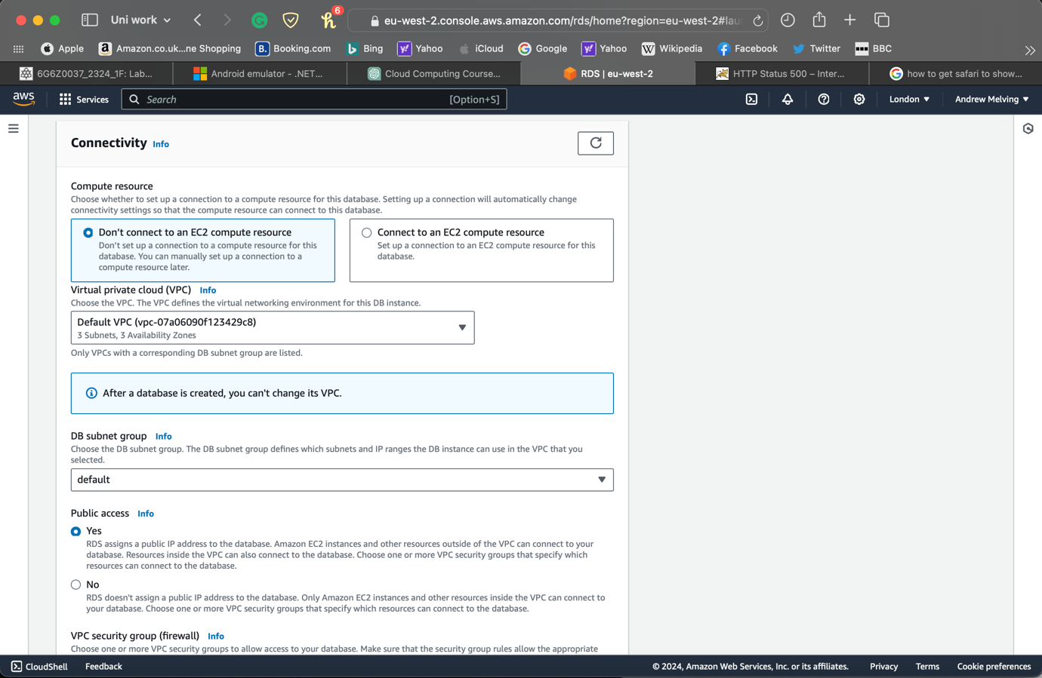

Finally, I clicked on **Create Database**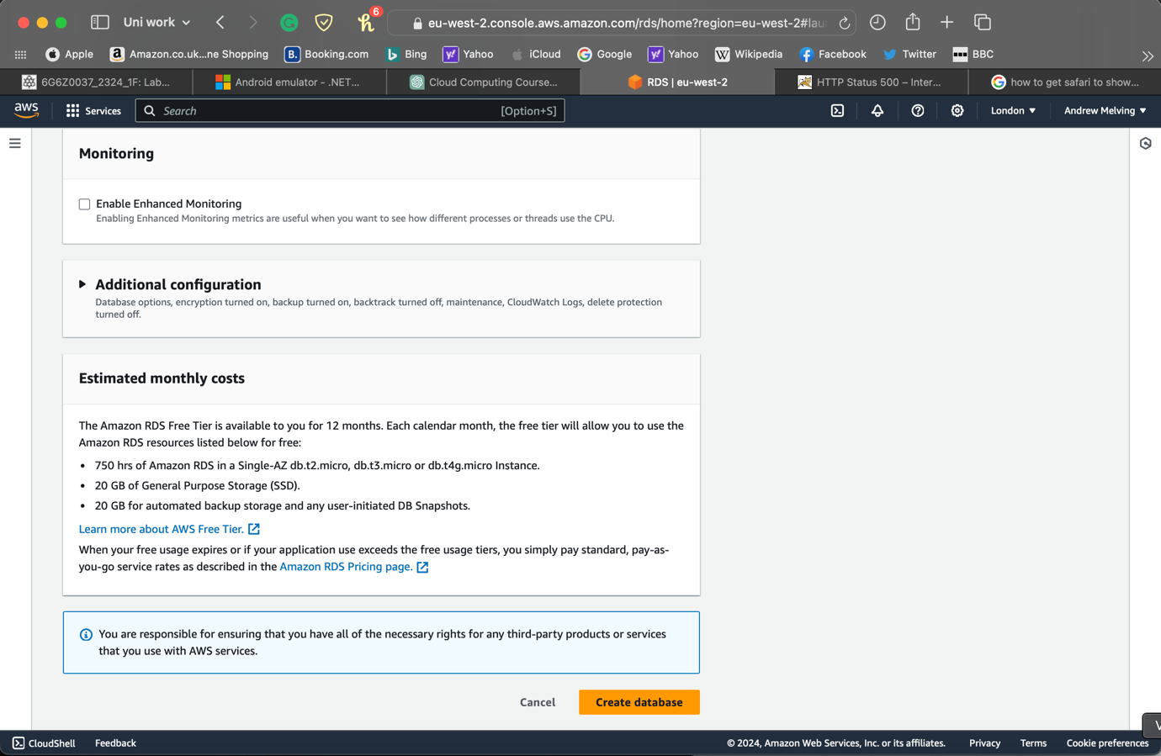

After a few minutes, my database is created with the endpoints and port shown.

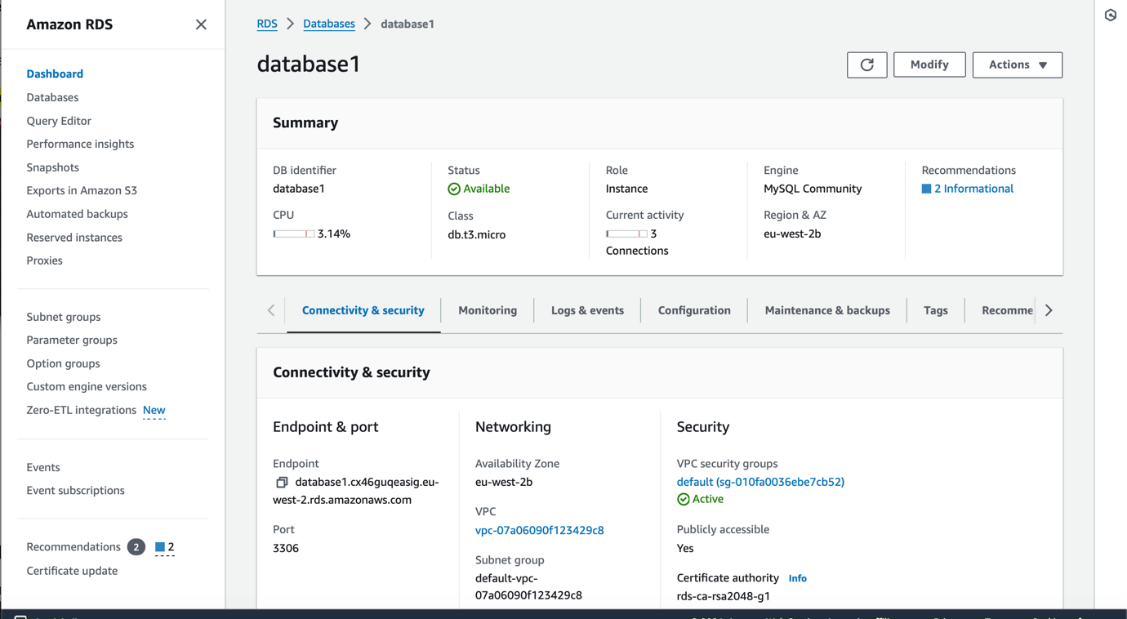

A new connection was set up using the RDS **endpoint** as the **Host Name** and entered the username and password

*Changed the database name

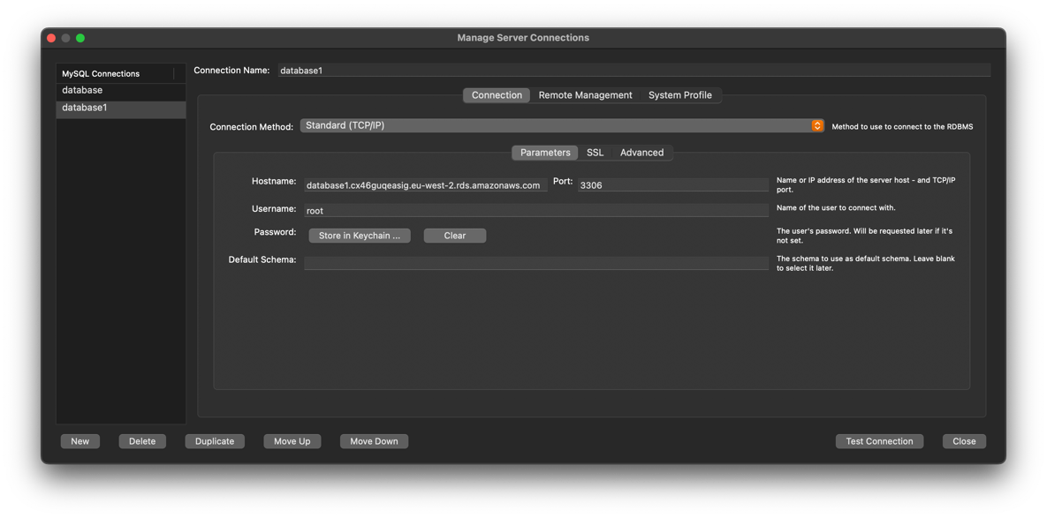

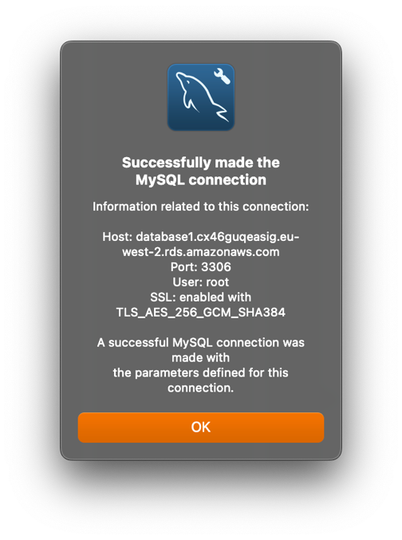

Then I went to the **dbconfig** of the DVD app and entered the configuration details

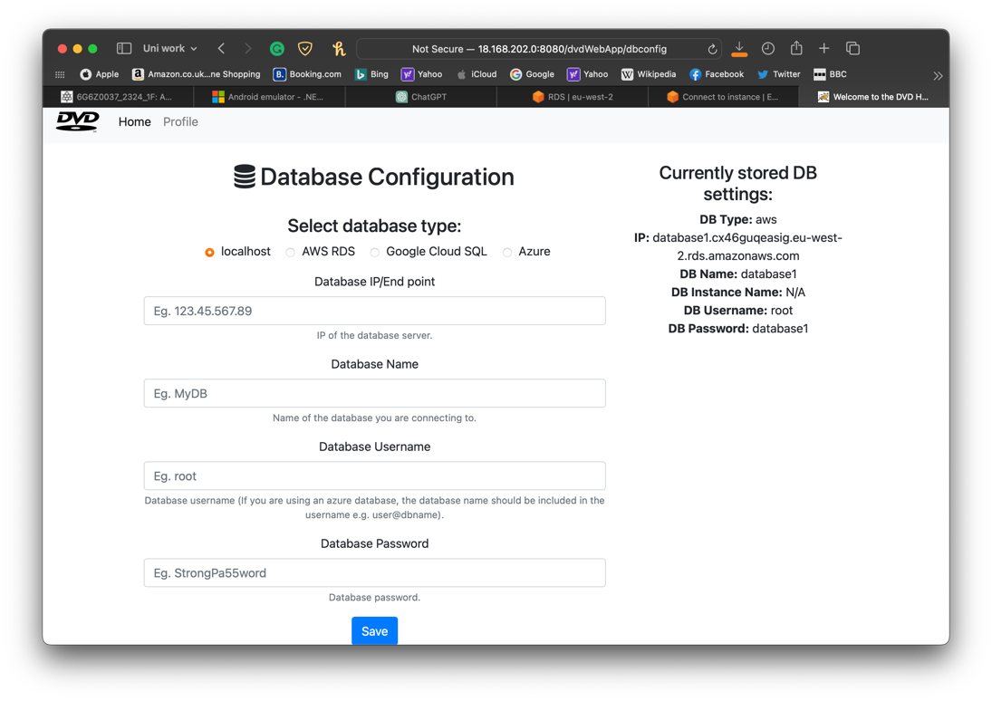

1. Serverless

To get started, I opened **Lambda** in the AWS console

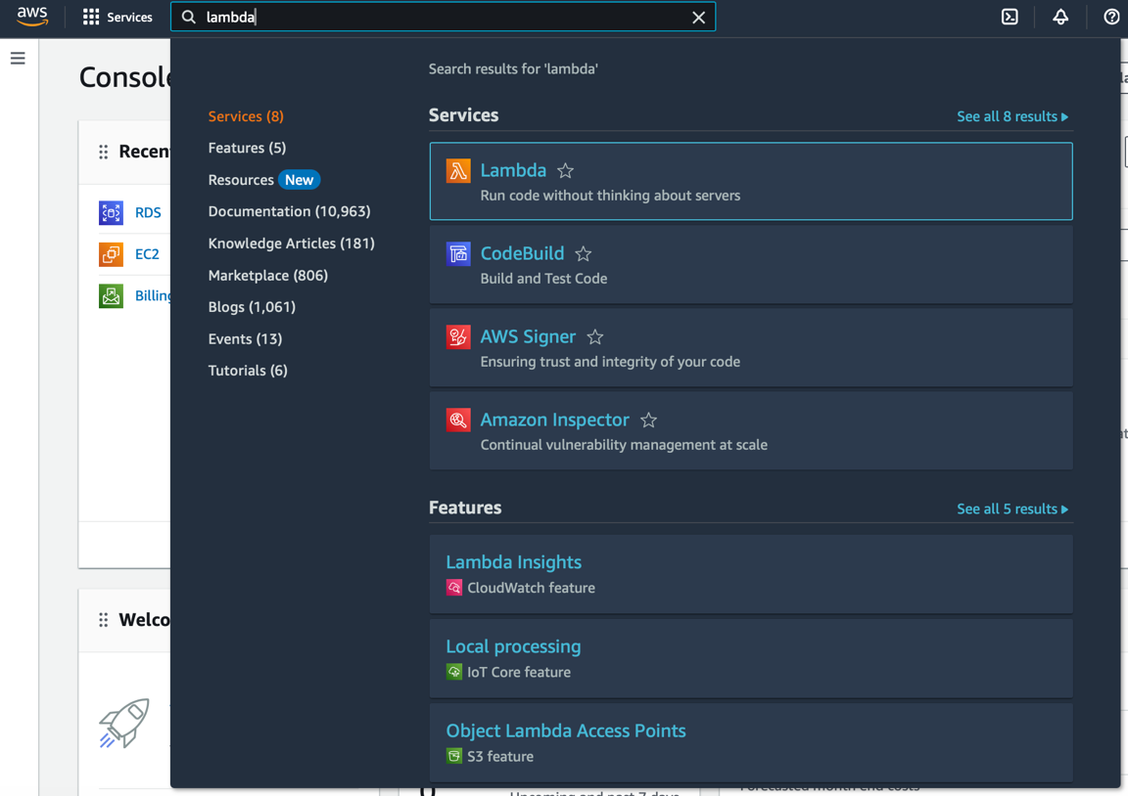

Then a **PasswordStrengthValidation** function was created

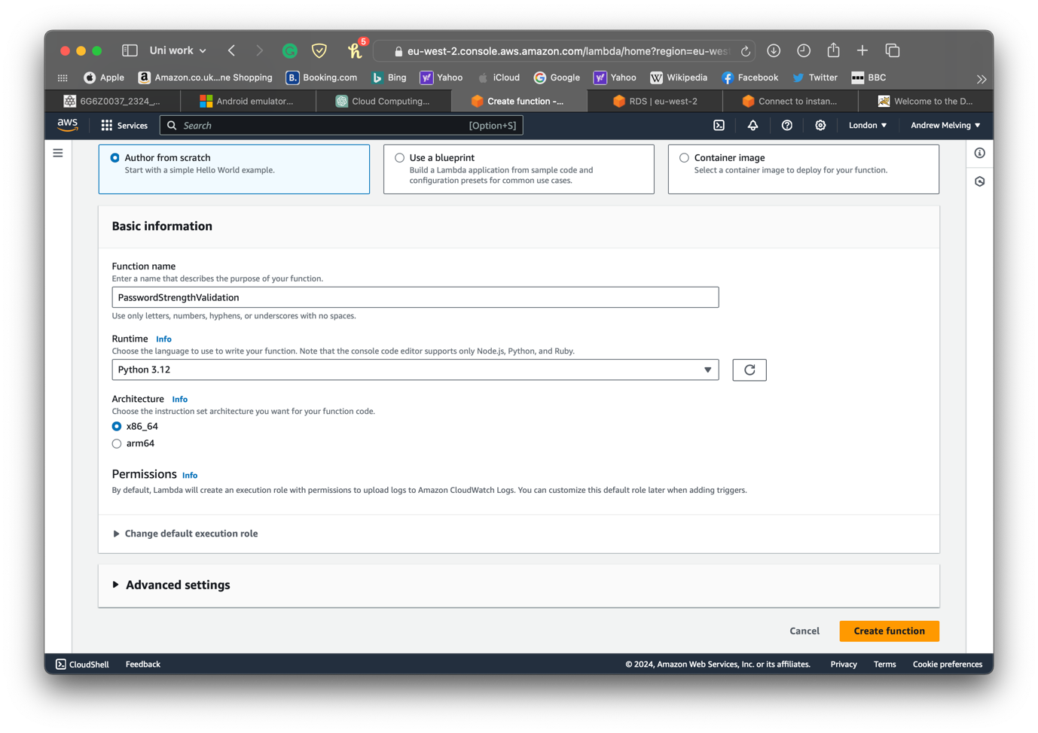

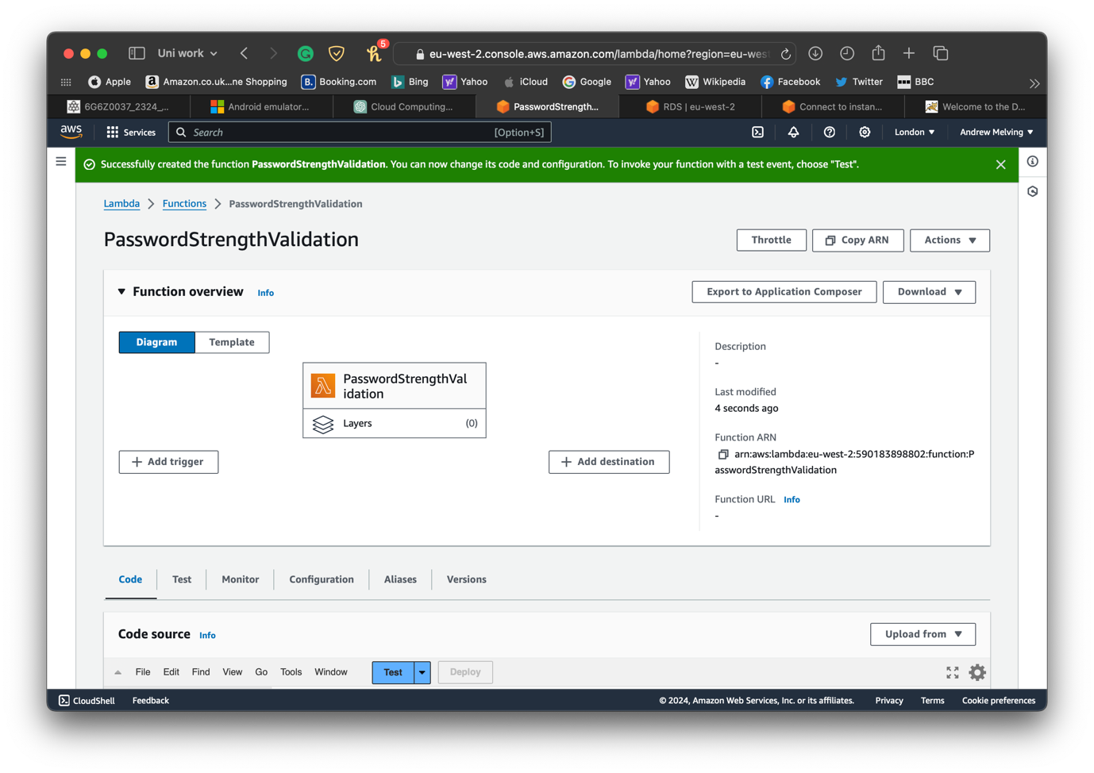

The code for the Lambda function is written in the code editor

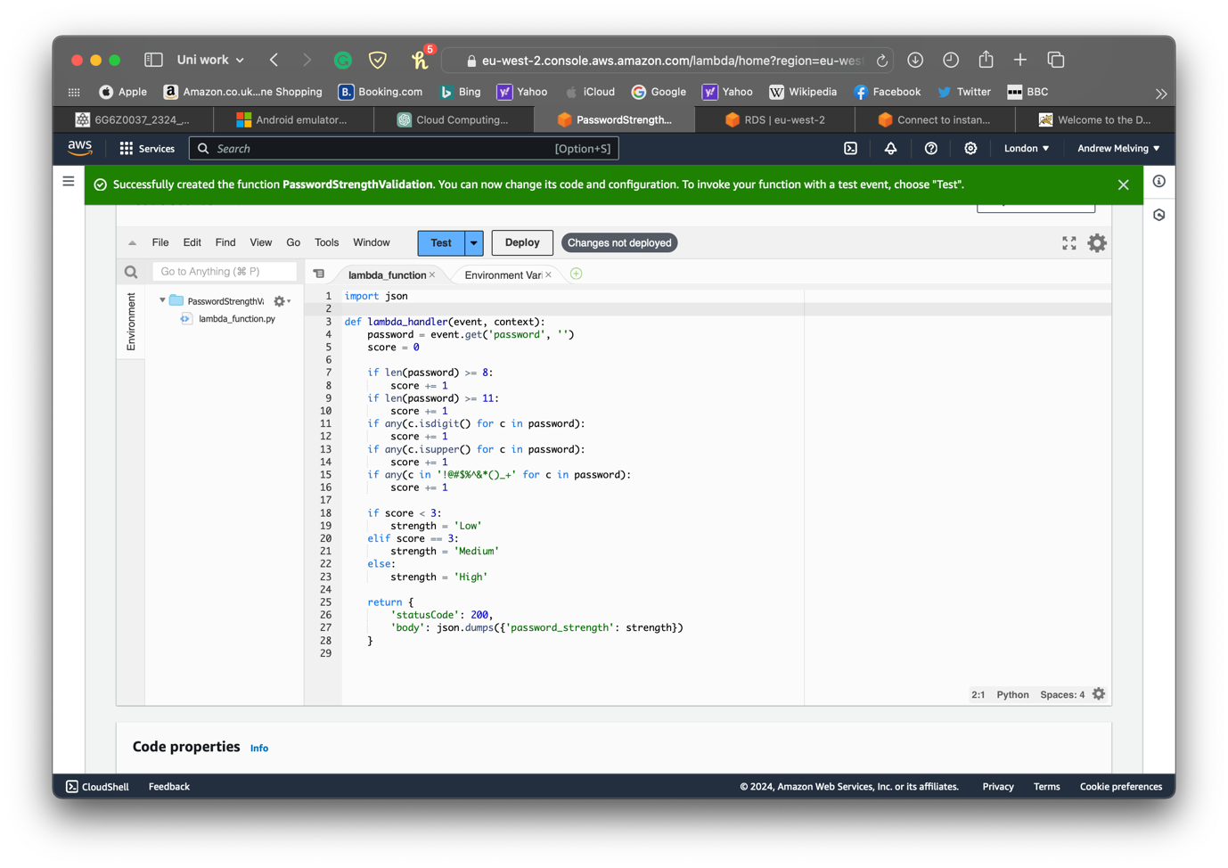

REST API Trigger was added to the function

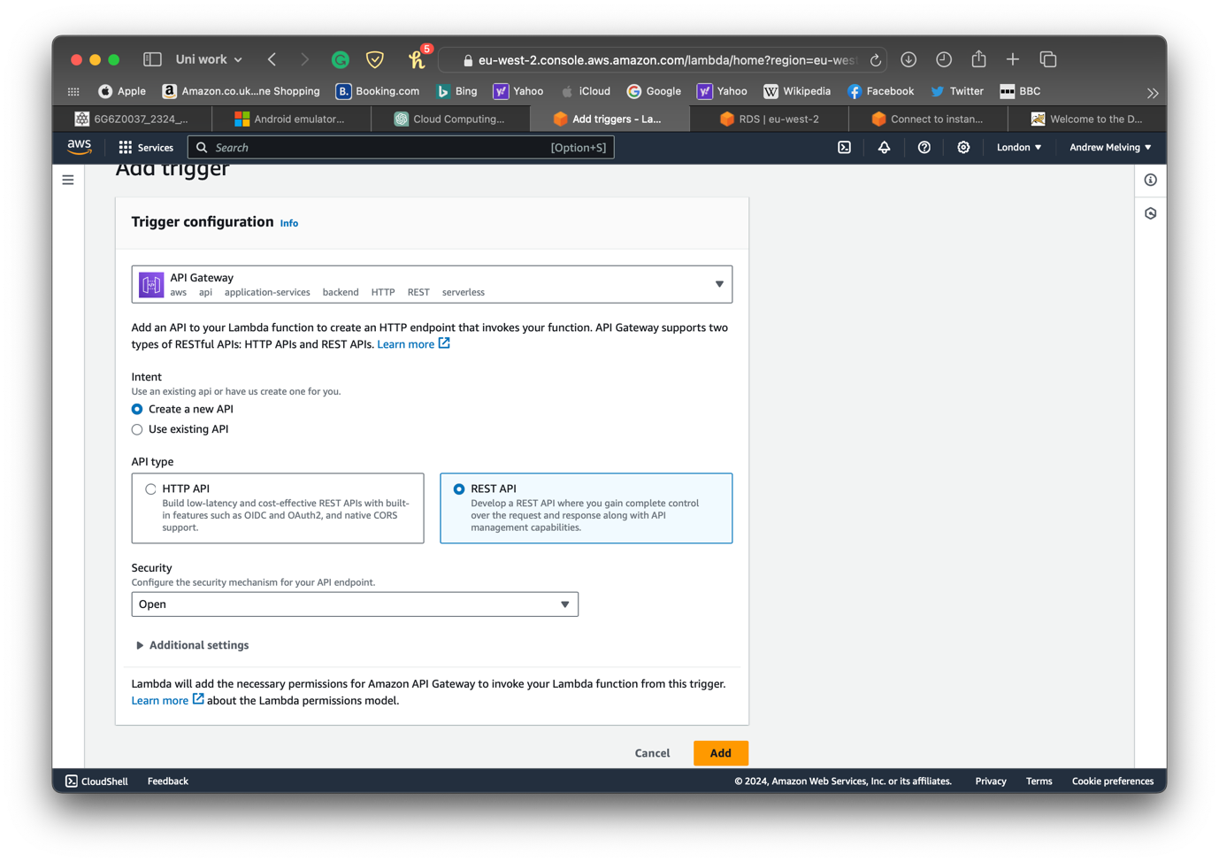

Go to the API settings and click **create method**

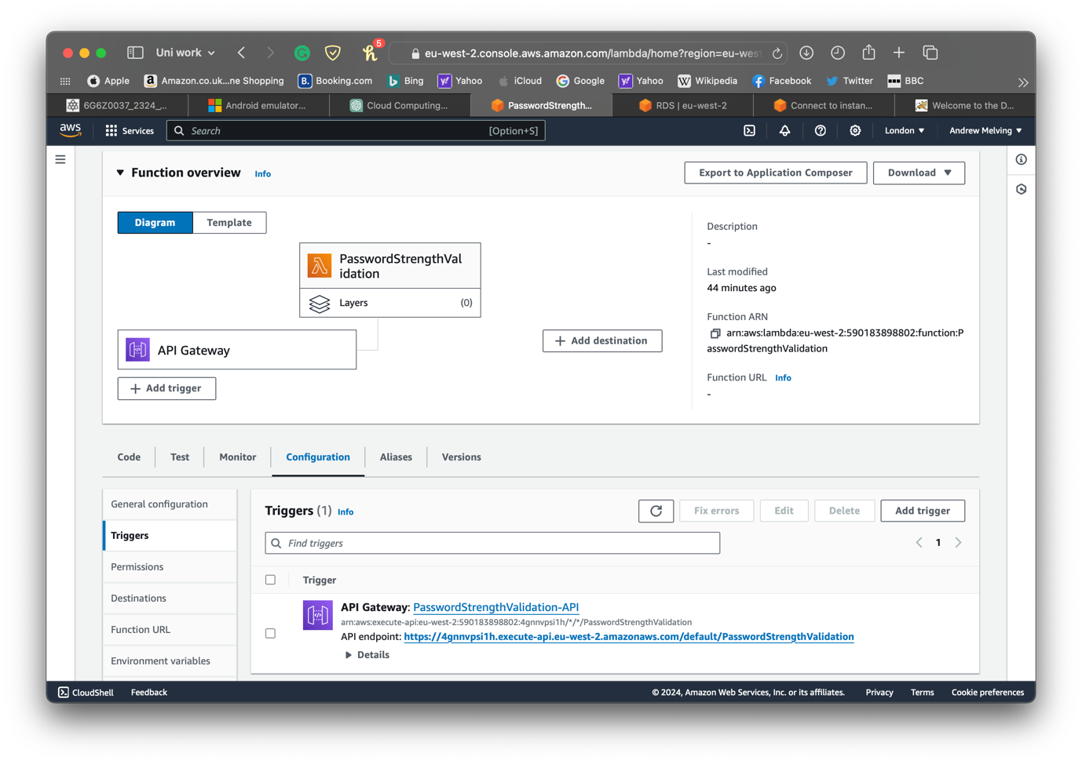

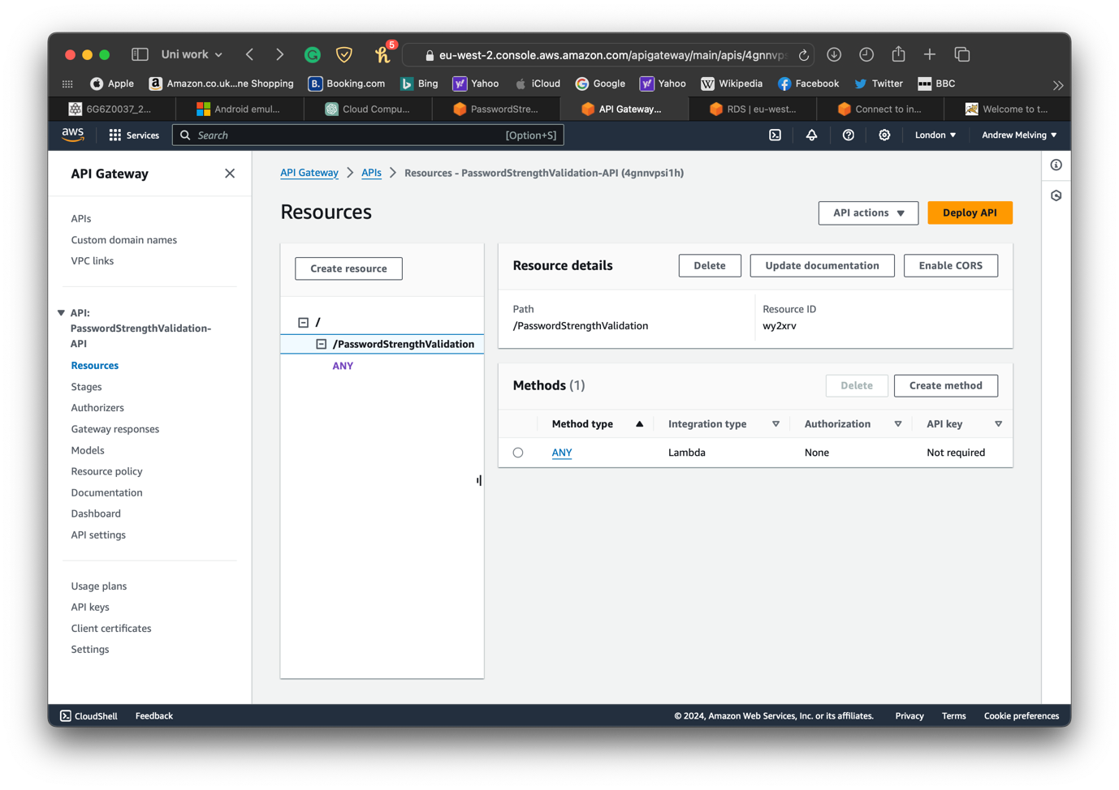

I created a **POST** request and attached the lambda function to it. Then clicked on **create method**

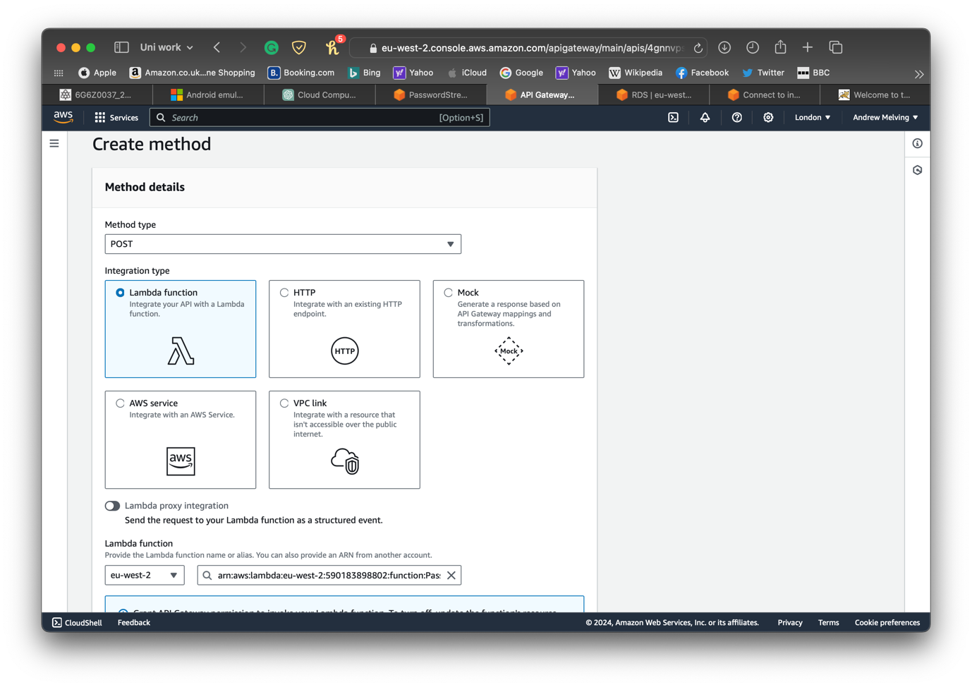

Clicked on **Deploy API** and the **Stage** screen appeared

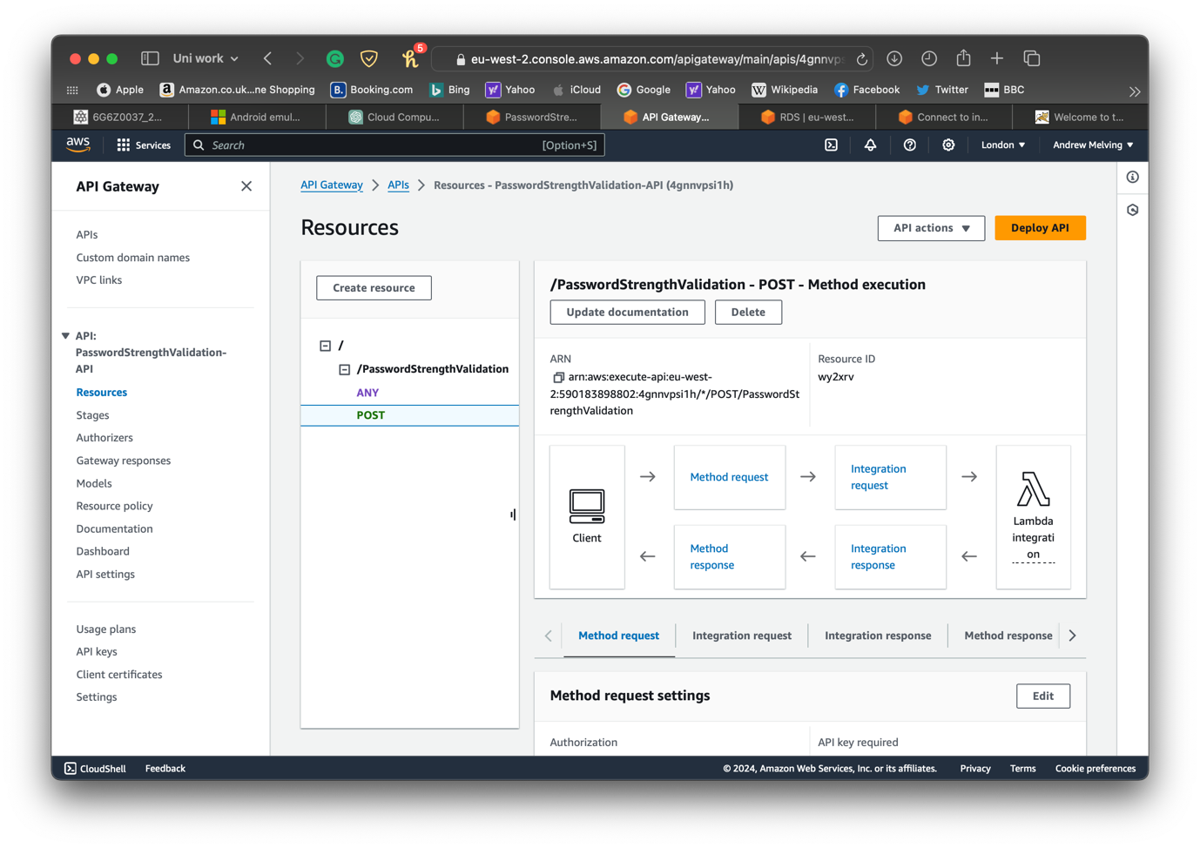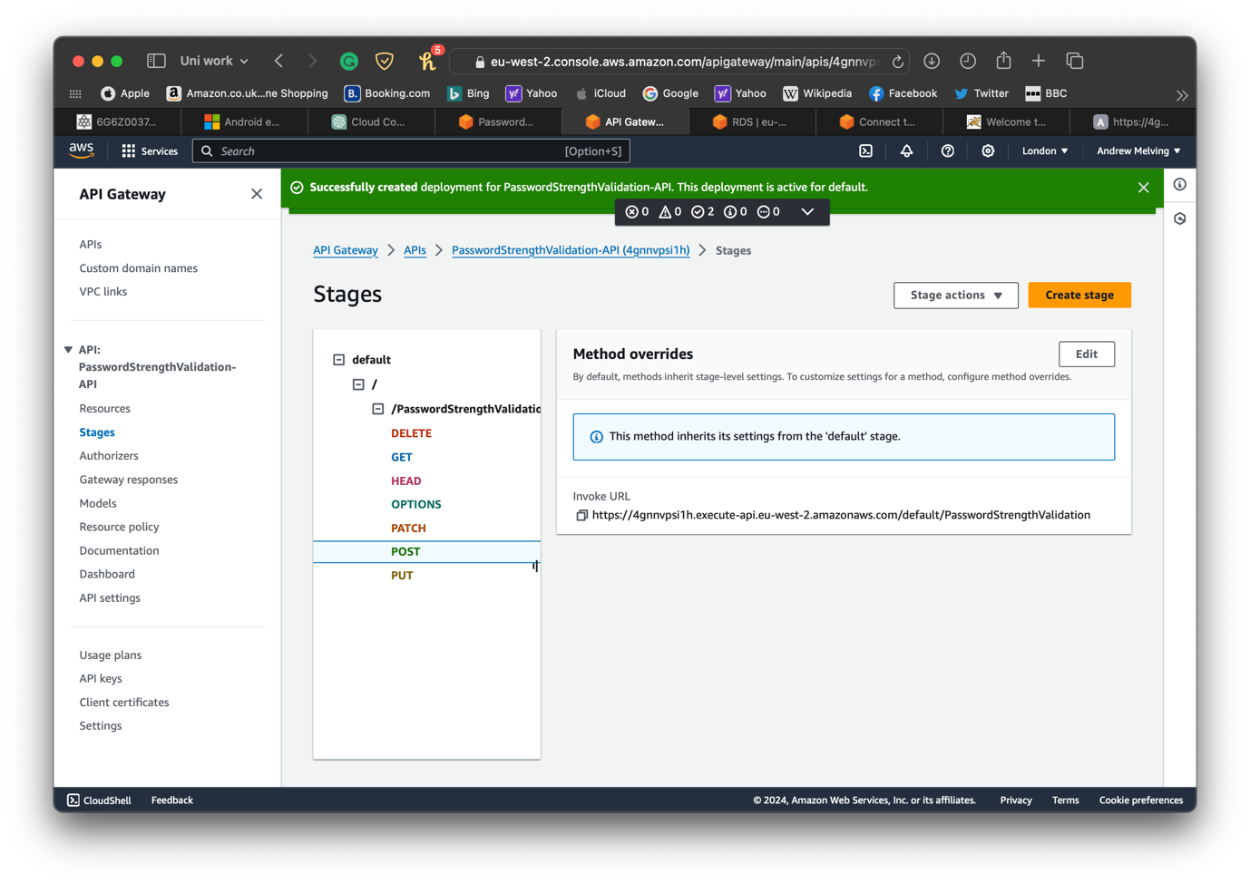

This was tested using tests with the following results

* **qwerty**

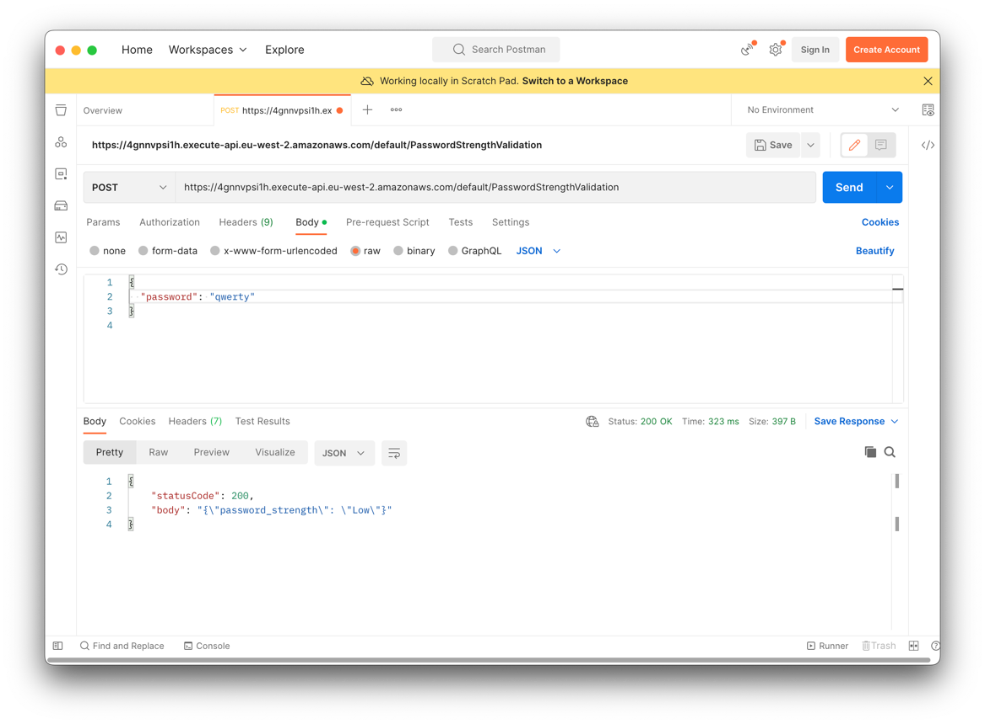

* **password**

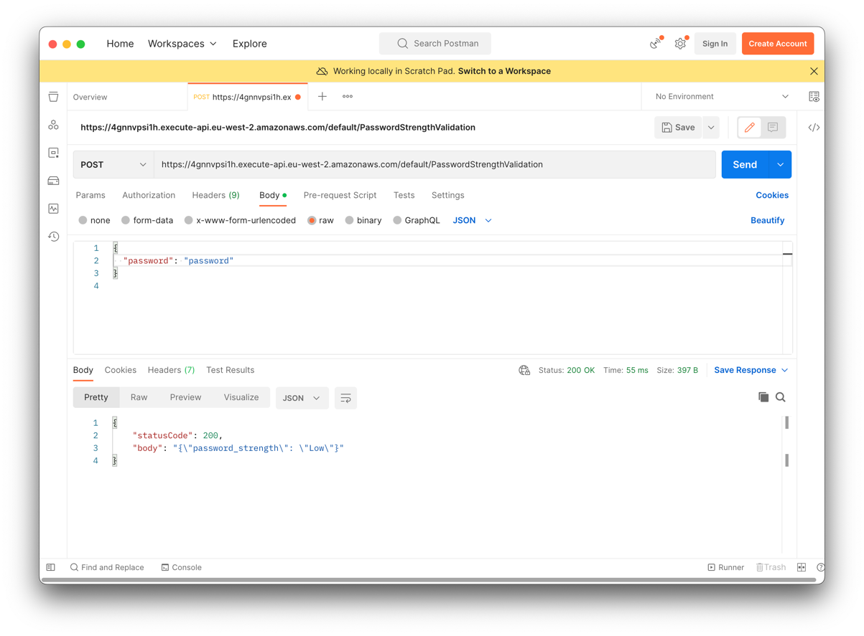

* **Pa55W0rd**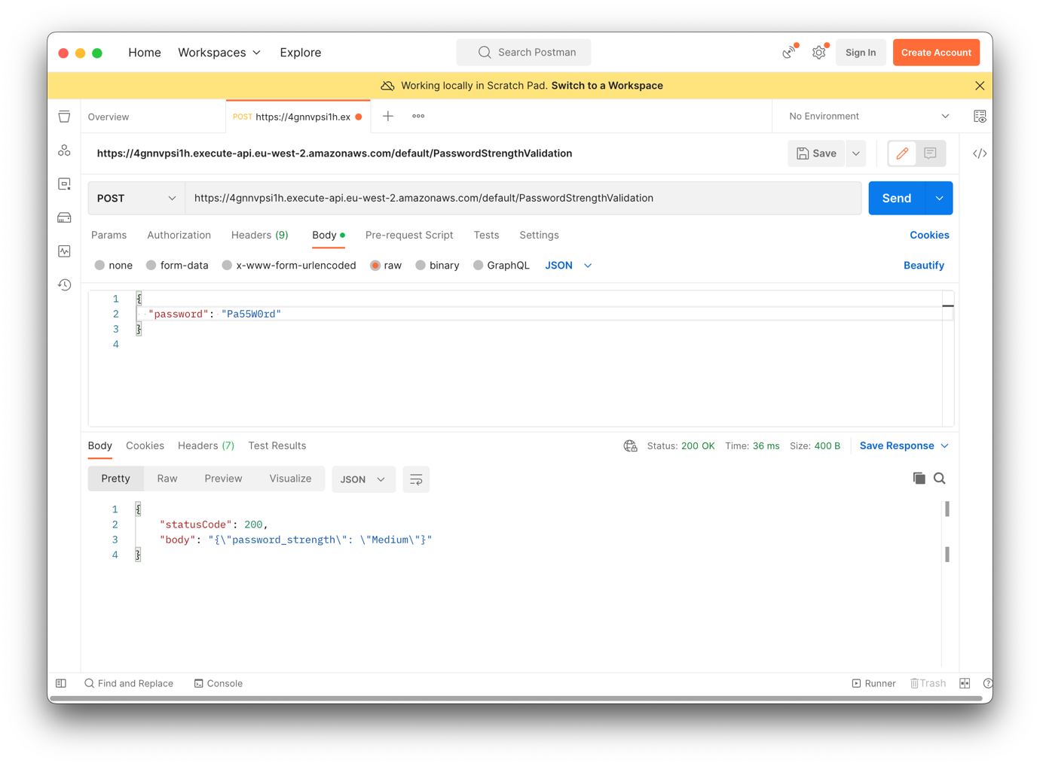
* **MuFC4L1F3!** 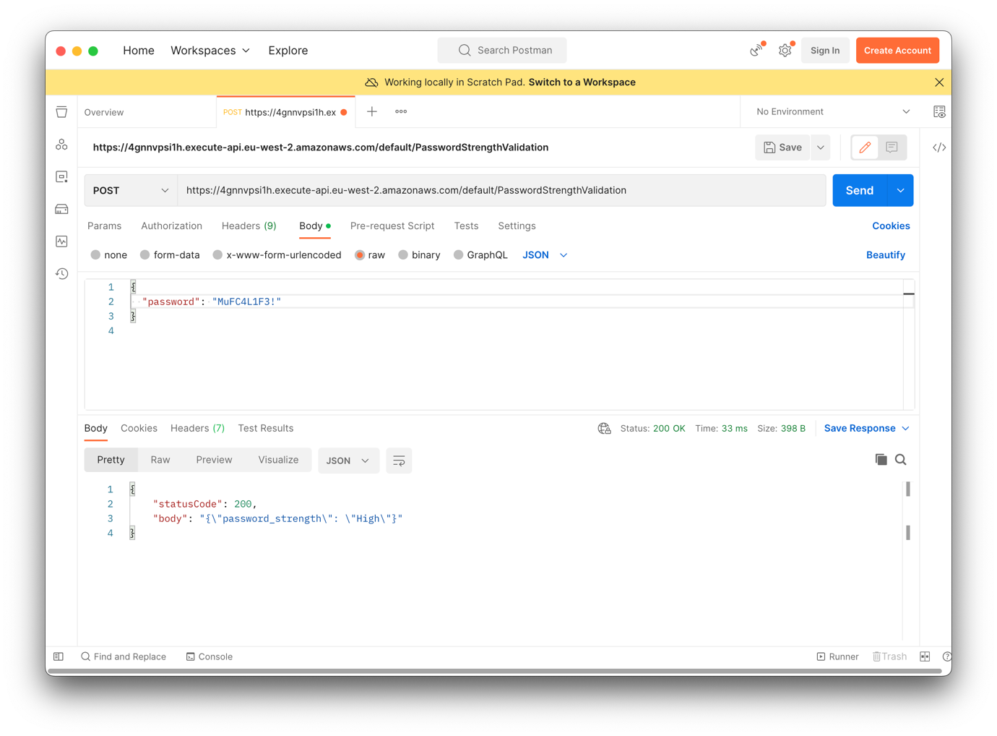
* **nbqLvH@b237L8$gEx0jxkc**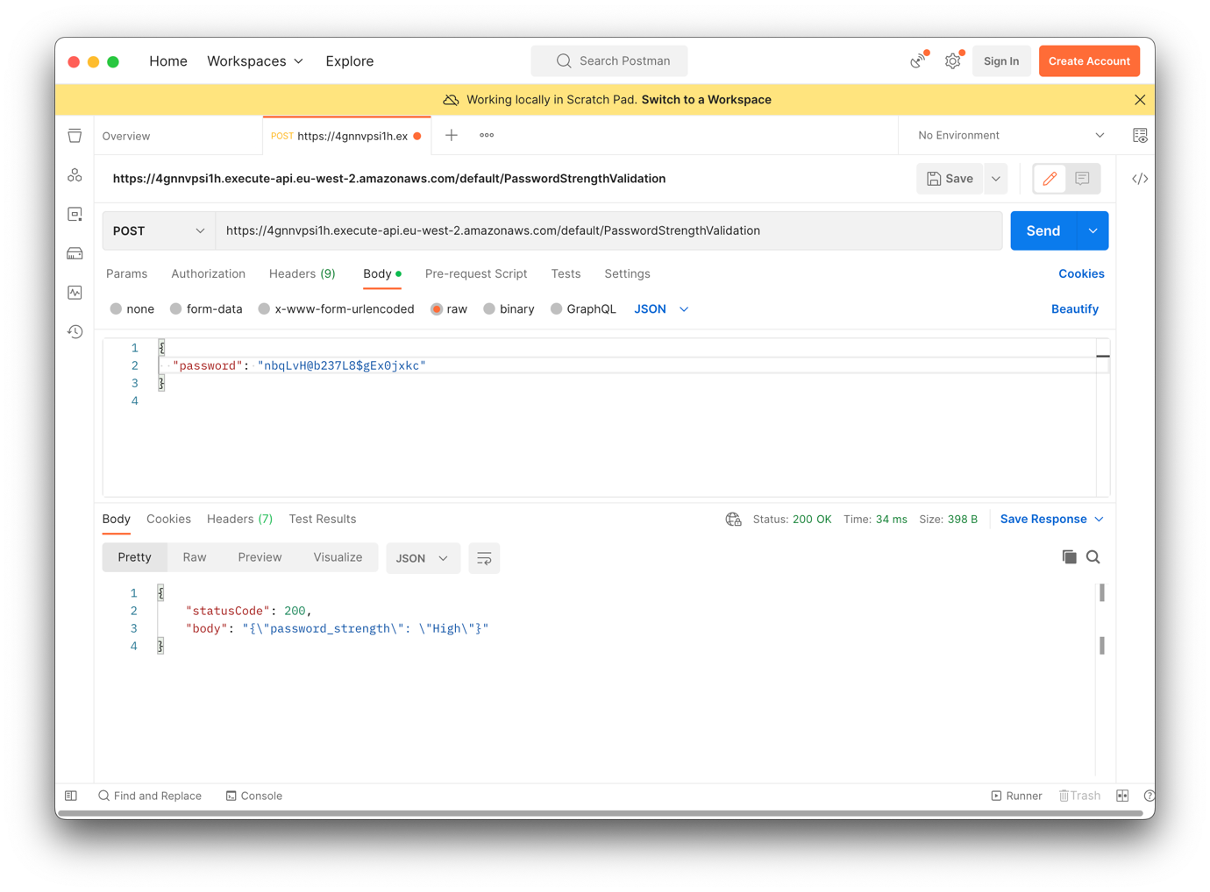

Cloud Function code – Python

import json

def lambda_handler(event, context):

password = event.get('password', '')

score = 0

if len(password) >= 8:

score += 1

if len(password) >= 11:

score += 1

if any(c.isdigit() for c in password):

score += 1

if any(c.isupper() for c in password):

score += 1

if any(c in '!@#$%^&*()_+' for c in password):

score += 1

if score < 3:

strength = 'Low'

elif score == 3:

strength = 'Medium'

else:

strength = 'High'

return {

'statusCode': 200,

'body': json.dumps({'password_strength': strength})

}

Link

[PasswordStrengthValidator.zip](https://stummuac-my.sharepoint.com/:u:/g/personal/21441545_stu_mmu_ac_uk/ERP484_DdoZNlGbIIeithqwBMGhxqM-7Jn5Zu9OqmLw3cQ?e=C02f0b)

<https://stummuac-my.sharepoint.com/:u:/g/personal/21441545_stu_mmu_ac_uk/ERP484_DdoZNlGbIIeithqwBMGhxqM-7Jn5Zu9OqmLw3cQ?e=0gSd9A>